**Sri Lanka Institute of Information Technology**



**Specialized in Cyber Security**

**Year 2, Semester 2**

**IE2062 – Web Security**

**Bug Bounty Journal**

|  |  |
| --- | --- |
| **Id Number** | **Name** |
| **IT21170416** | **Pemarathna I.R.C** |

**3rd May 2023**

**Summary of the day's activities**

**Robot attack** vulnerability identification utilizing Nmap zap and any other tools to explore the website and locate high-level vulnerabilities.

**Vulnerabilities discovered or explored**

* Information gathering

🡪 HackerOne guidelines

URL: <http://cyberghostvpn.com/>

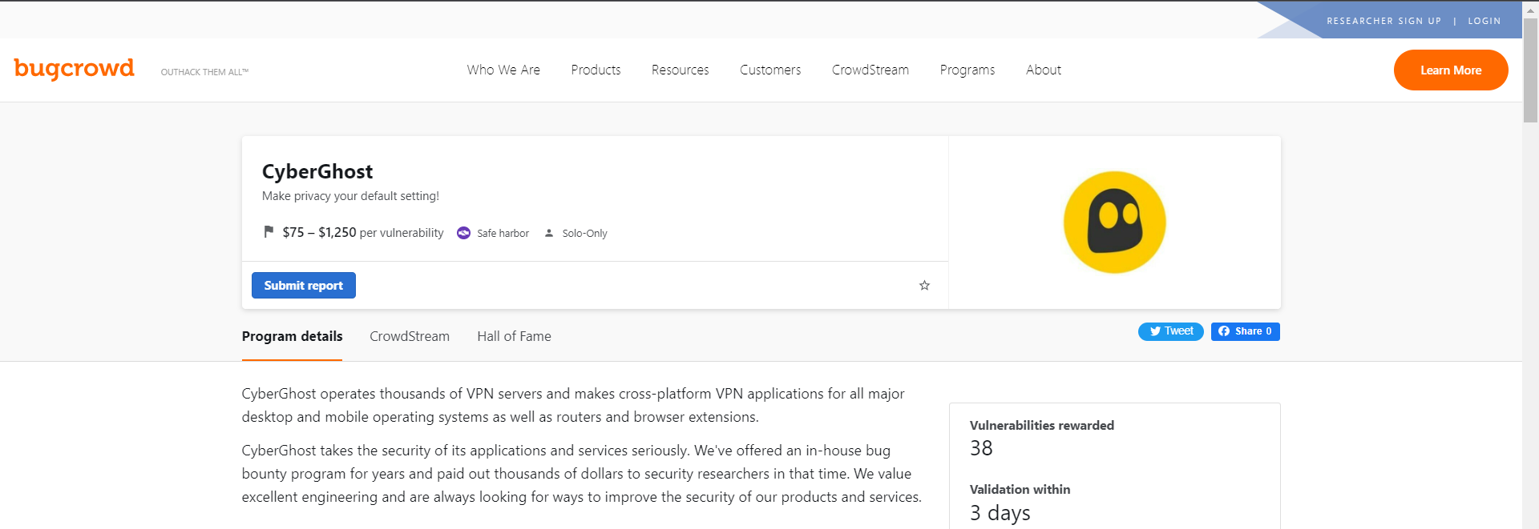

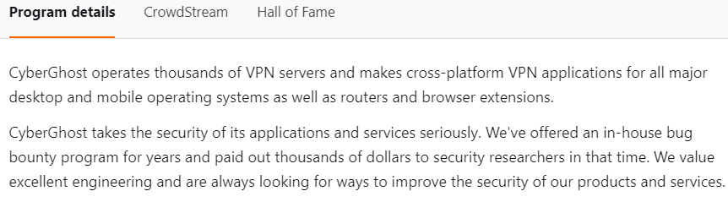

**Scope**

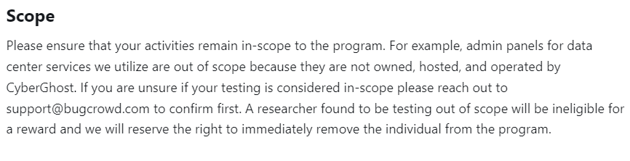

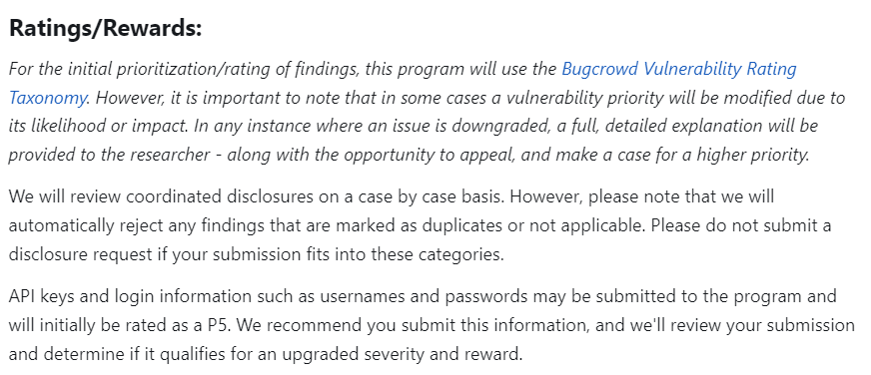

**Scope**

* In Scope

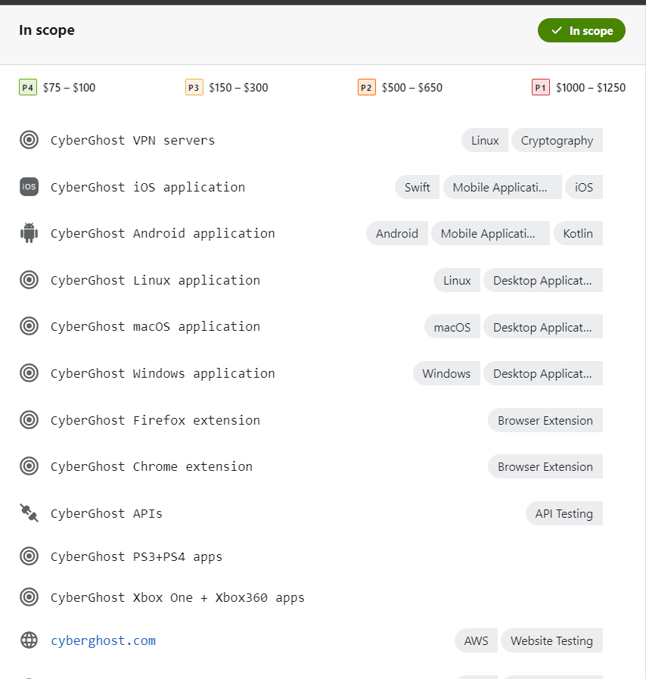

* Out Scope

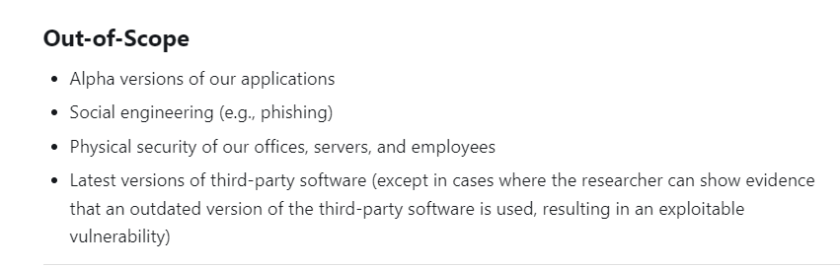

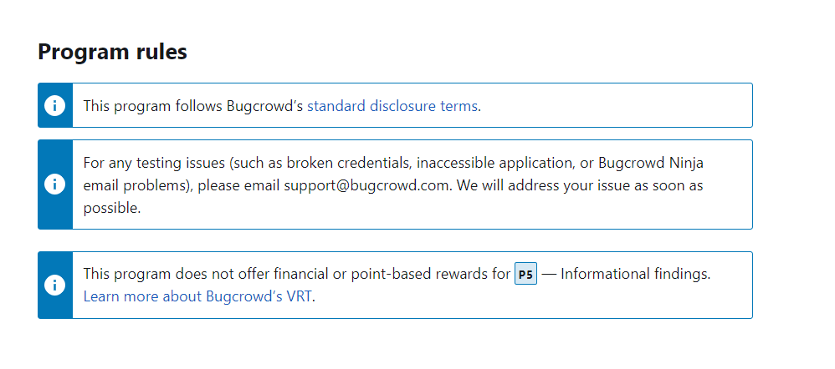

🡪 **About the website**

A well-known provider of VPN (Virtual Private Network) services is CyberGhost. By encrypting user traffic and routing it across a global network of computers, the firm enables anyone to access the internet safely and privately. The following are some significant details of the CyberGhost website:

The primary internet presence of the business is on the CyberGhost website. It provides you with information on their VPN services, their advantages, their payment options, and other crucial details.

characteristics and Advantages: The CyberGhost VPN website highlights the characteristics and advantages of using it, including anonymous surfing, data encryption, access to content that is geo-restricted, safety on public Wi-Fi networks, and preventing online tracking.

Plans for subscribing: The website offers a variety of subscription plans, including monthly and annual subscriptions as well as plans compatible with Windows, Mac, Android, iOS, and other devices. There can also be details on costs and special offers.

User interface: The website features a user-friendly interface that enables users to navigate and get the information they need. Some of the sections it could contain include "home," "about," "features," "pricing," "support," and "blog."

Support and Resources: The website of CyberGhost typically offers live chat options, FAQs, setup instructions, and troubleshooting advice. The use of the VPN service is made easier by these tools.

material on security and privacy: The company's dedication to user privacy, its logging practices, and the security measures it has put in place to secure user data may all be covered in the website's material.

Downloading and Configuring: The CyberGhost VPN app download links may be found on the website for the majority of users. The website provides instructions for downloading, setting up, and configuring the VPN software on many platforms.

* + About the Sub Domain that are discovered ([cyberghostvpn.com](https://www.cyberghostvpn.com/))

An extension of a larger name is a subdomain. It is created by placing a dot between the primary domain name and the prefix. A subdomain, in the case of "cyberghostvpn.com," could be a subcategory or a particular section of the home page.

Introduction:

This premium VPN service is the best.

Featured activities and traits:

CyberGhost VPN provides users with access to virtual private network services that enable secure and private internet connections. The webpage demonstrates the capabilities and benefits of CyberGhost VPN.

Plans for subscribing: The website provides a variety of subscription options, including options for various devices, operating systems, and lengths of time (monthly or yearly). Users can choose a package that matches their needs and budget.

Downloading and Configuring: The CyberGhost VPN app can often be downloaded from the website for a variety of operating systems, including Windows, Mac, Android, iOS, and more. The instructions for downloading, installing, and configuring the VPN software are frequently included.

Features and Advantages: The website discusses the attributes and advantages of using CyberGhost VPN, including anonymous browsing, data encryption, network security on public hotspots, access to geo-restricted content, and preventing online tracking.

Support and Resources: The CyberGhost VPN website often offers live chat options, knowledge base articles, setup tutorials, and troubleshooting guides for customer support. With the aid of these tools, users may successfully set up and utilize the VPN service.

Information on Security and Privacy: The website typically contains details on CyberGhost VPN's security precautions, encryption techniques, and privacy policies. Users can learn how much the business values preserving their privacy and their personal information.

Testimonials and reviews: To demonstrate how dependable and effective their VPN service is, CyberGhost VPN may have testimonials and reviews from users and subject-matter experts.

Blog and news section: The website may feature a blog or news section with articles, updates, and other details concerning VPN technology, online privacy, and security.

**Challenges faced and how they were overcome**

Multiple times when I used my own primary VPN, that website restricted my IP address.

challenging to visit the webpage

Taken more time than expected.

* **New tools**

**Netspaker**

Netsparker is an Enterprise Dynamic Application Security Testing (DAST) tool that can be set up in any way you want. DAST tool talks to a web application through its web front-end in order to find any security holes in the web application.

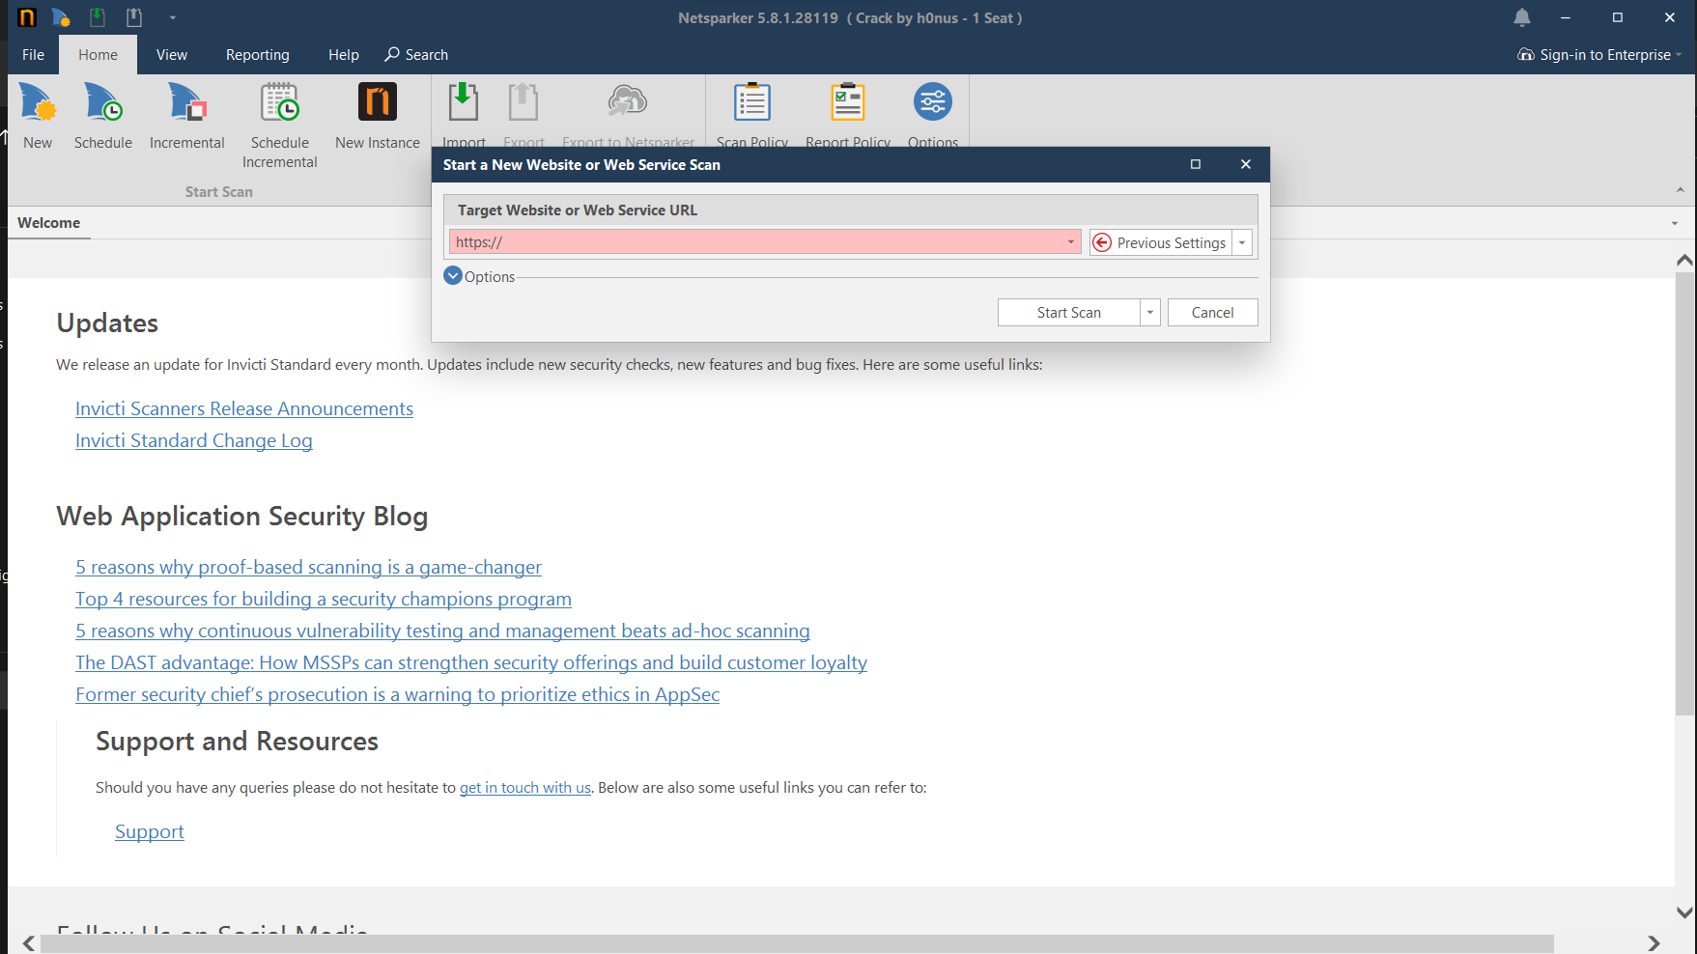

In the search bar you need to add the target you want to check.

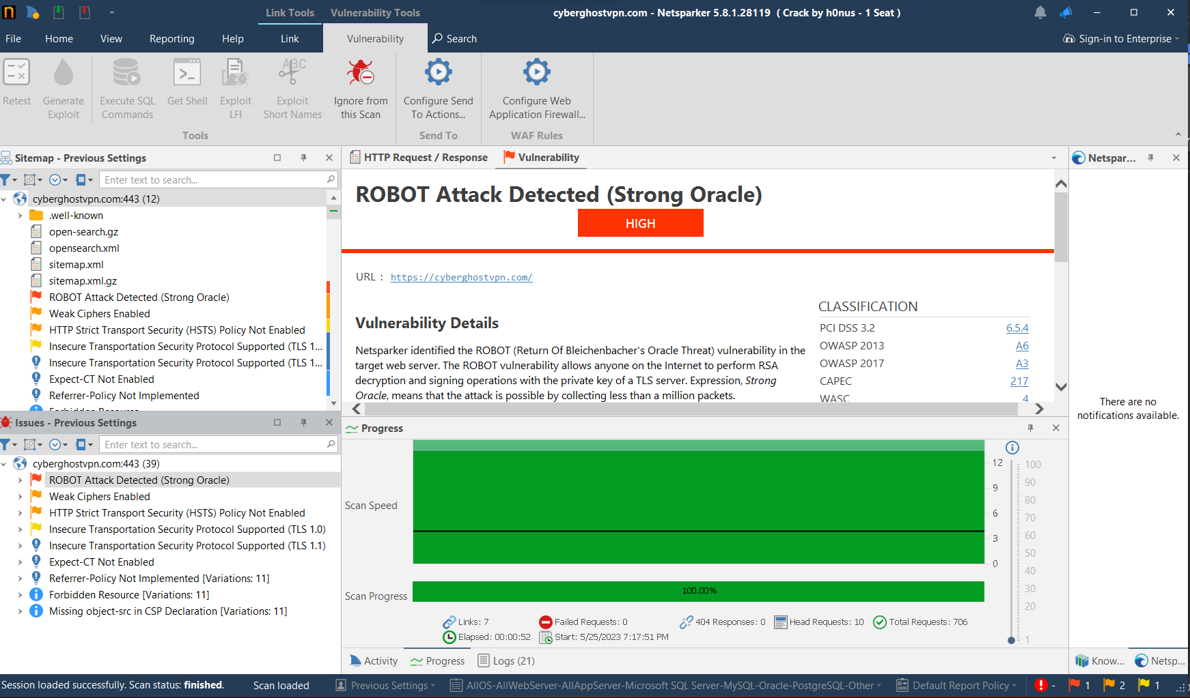

This software gives this kind of output and if you want, you can generate reports.

In the report had so much information about the you catches vulnerabilities.

* **Techniques**

Nmap command:

Command: nmap -sV -sC cyberghost.com

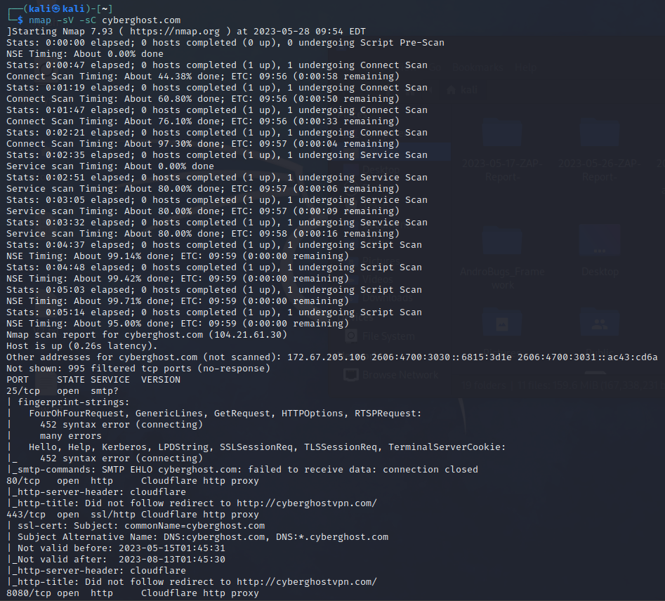

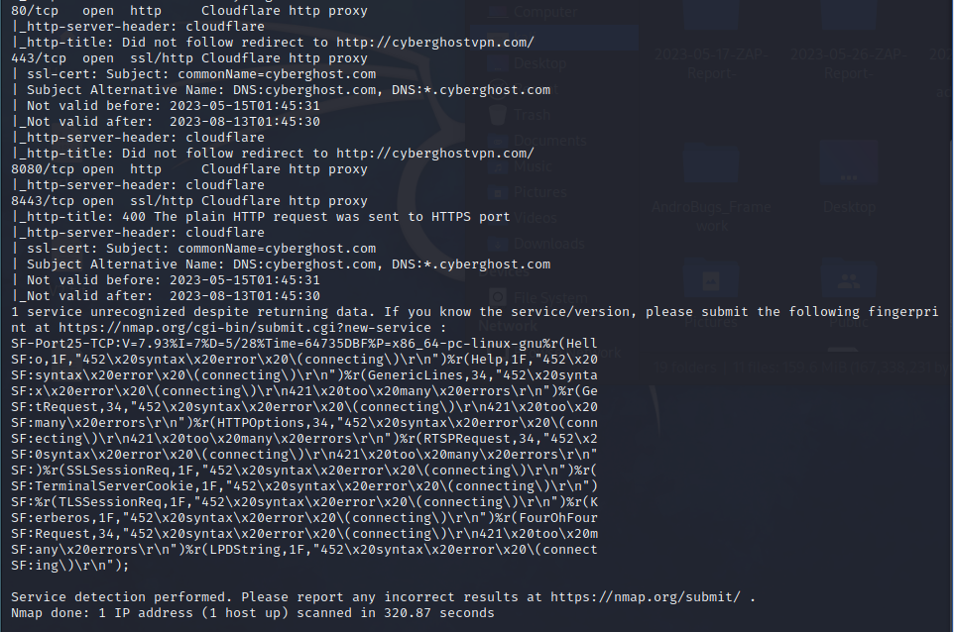

On the nmap tool I can get some open port with 200 ok request and some information about the website basic .but I can found the exact robot attack vulnerbility related information.

But netspaker gives the high detection in the (strong oracle) robot attack detection . there have more information about the such vulnerility.

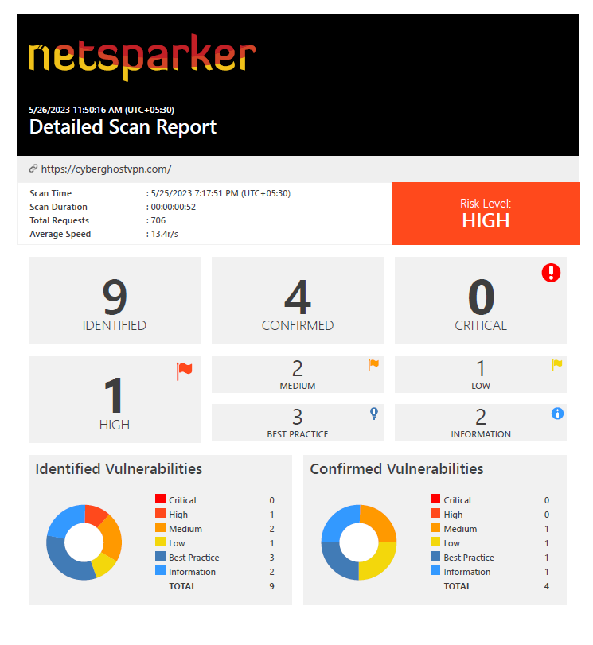



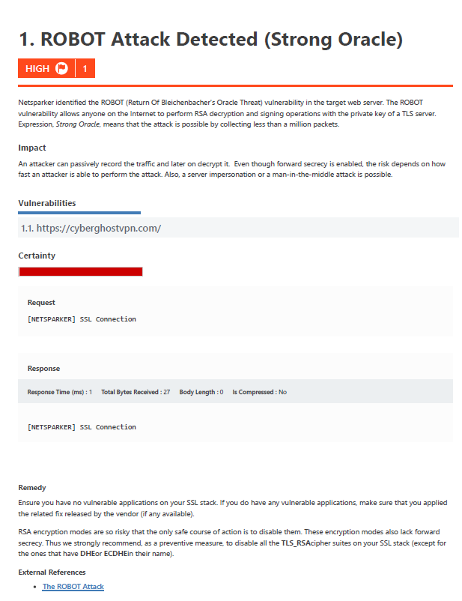

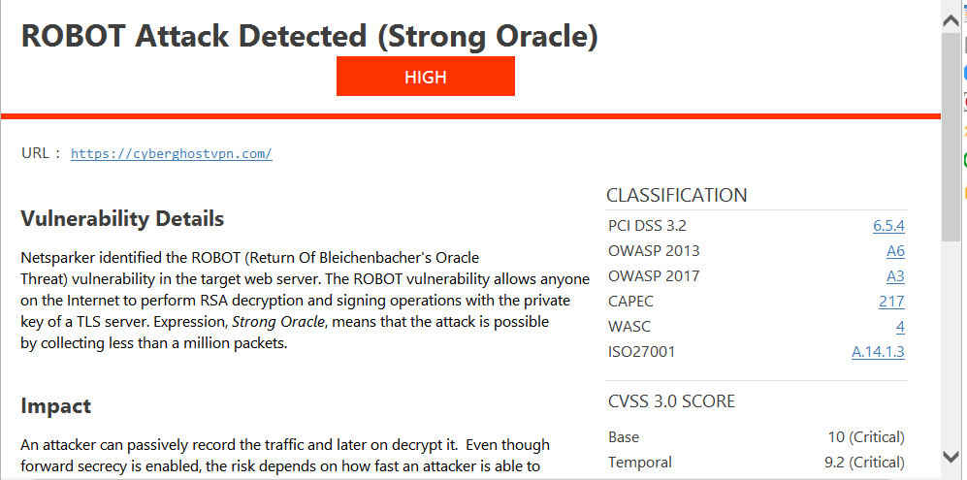

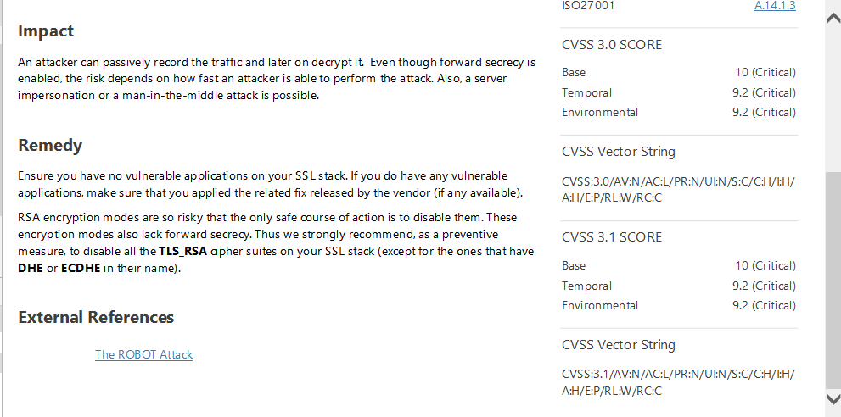

According to netspaker I can found the reference for this vulnerbility site.

I follow this site and get the more details about the this vulnerbility.

* **concepts learned**

# Robot attack Detected(strong oracle)

**According to invicti website(new version of the netspaker software )**

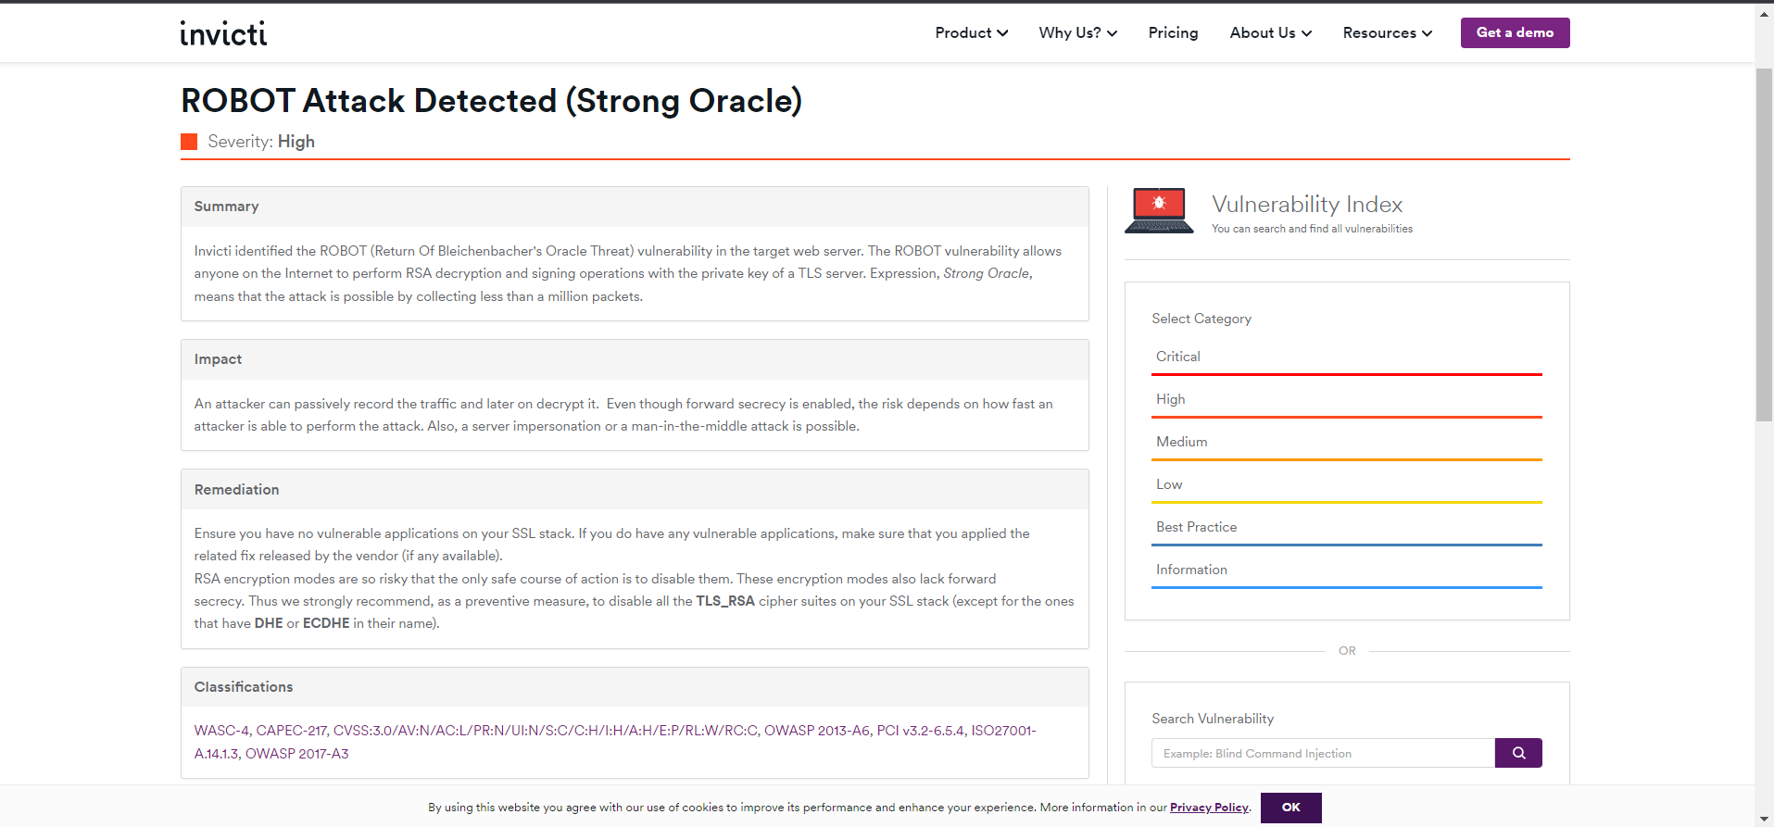

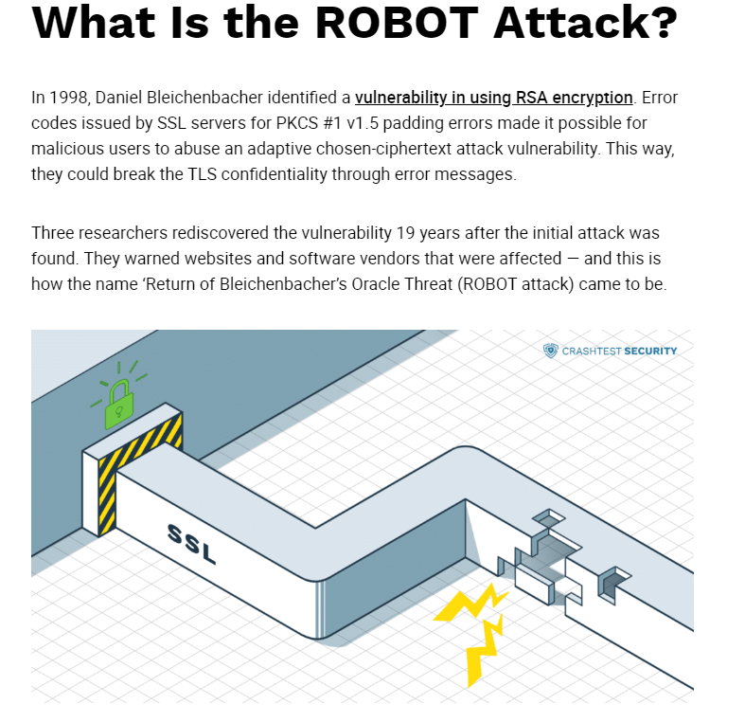

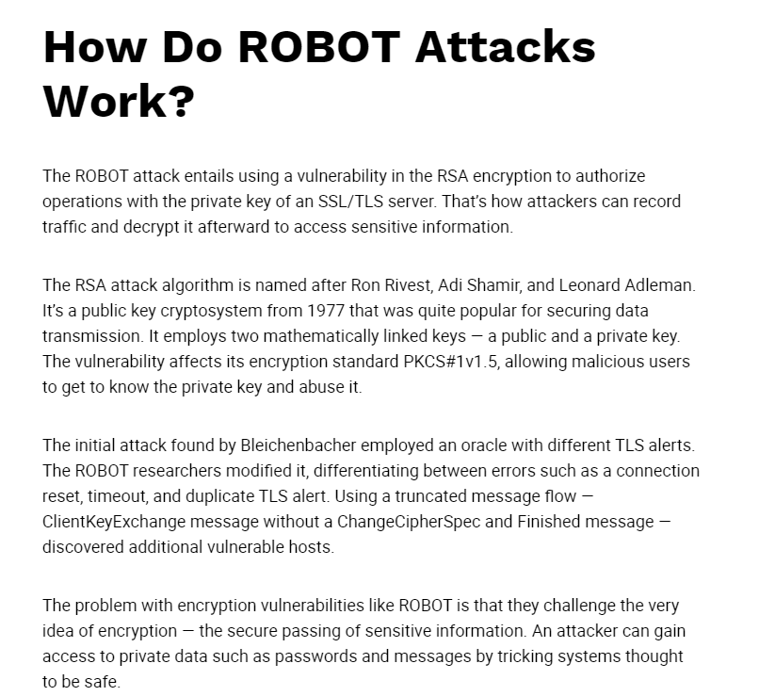

**Reflections and takeaways**

The term "Robot attack detected (strong oracle)" typically refers to a security feature that apps or websites utilize to identify and prevent harmful or automatic activity. Consider the following as you learn more about this type of assault detection:

The presence of a "robot attack detected (strong oracle)" indication on a website or application indicates that security measures have been put in place to guard against automatic attacks. This demonstrates that people are aware that safeguards must be taken to safeguard systems and user information.

Websites and apps may suffer from automated attacks, which are frequently carried out by malicious scripts or bots. The system can prevent unauthorized entry, data leaks, and other negative outcomes by detecting and thwarting these threats.

Ensuring that legitimate users may access and utilize the website or app without interruption from malicious automated actions can help to improve the user experience.

Security-Usability Finding a balance between security and usefulness is just as vital as putting security measures in place. It is upsetting when security precautions are taken and individuals who are attempting to use a website legally are prevented. If you want to keep people secure without negatively impacting their experience, finding the perfect combination is crucial.

Continuous monitoring and adaptation: Attackers always devise new strategies to get around security measures since the environment for automatic attacks is constantly changing. It's crucial to continually monitor and analyze attack trends, as well as adjust security precautions, to keep ahead of potential dangers.

Users' education and comprehension: Users' trust and understanding can be increased by explaining security measures and their purpose to them. Users ought to be aware of how crucial security is, what steps are being taken to safeguard their information, and how to surf securely.

Collaboration and Information Sharing: Sharing information about emerging threats and attack strategies among organizations can be beneficial. By using this information, security may be increased and automatic hacks can be prevented to a greater extent.

In general, a warning like "robot attack detected (strong oracle)" indicates that security is being handled pro-actively. It serves as a reminder that automated attacks are still a concern and that in order to secure systems and user data, robust security measures must be put in place.

**20th May 2023**

**Summary of the day's activities**

**Weak Ciphers Enabled** vulnerability identification utilizing netsparker and any other tools to explore the website and locate mid-level vulnerabilities.

**Vulnerabilities discovered or explored**

* Information gathering

🡪 BugZero guide lines

URL: <https://cert.gov.lk/>

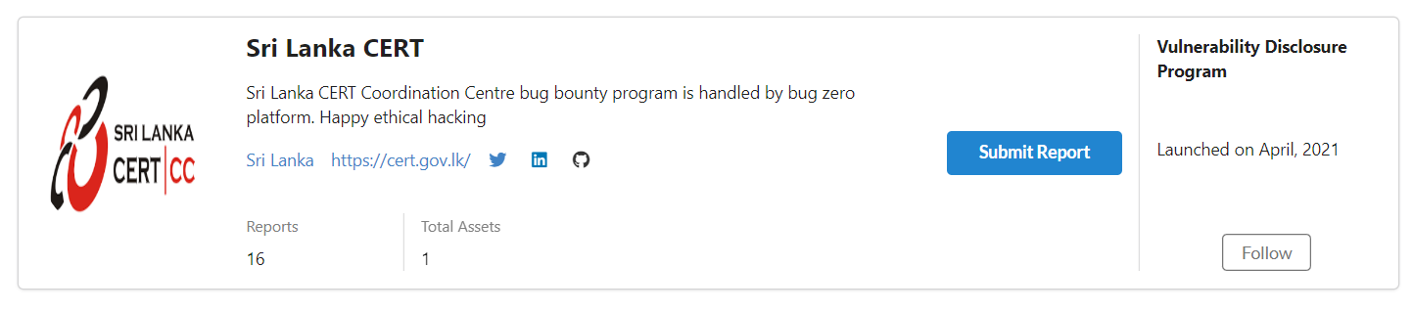

**Policy**

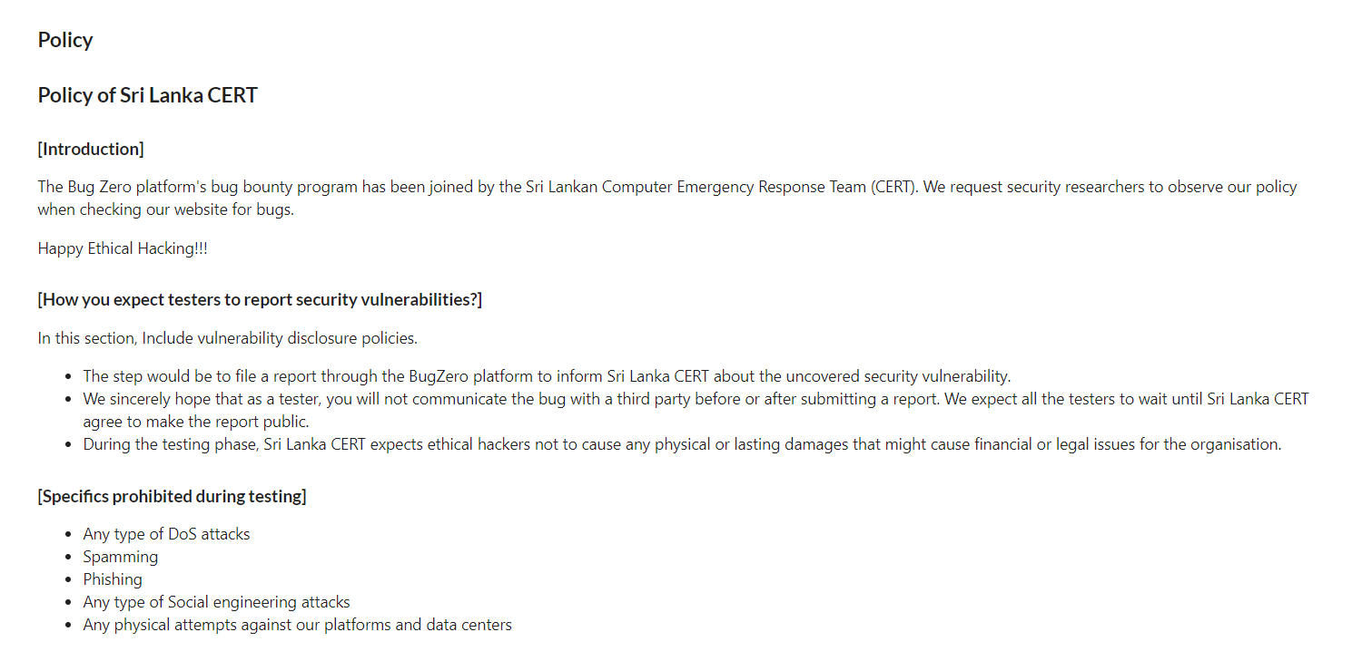

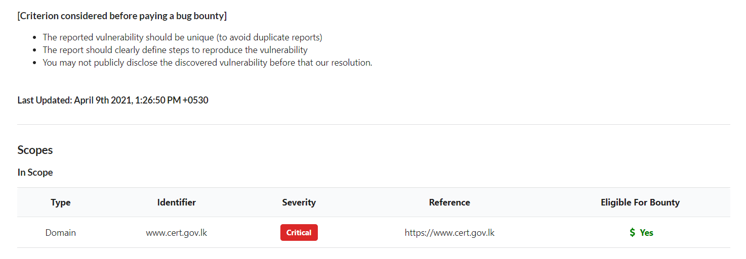

🡪 **About the website**

The ICT Agency of Sri Lanka (ICTA) created Sri Lanka CERT | CC as the country's national CERT in 2006. The primary driver for the creation of CERT was to address the anticipated rise in cyber security issues brought on by Sri Lanka's IT infrastructure's explosive expansion. It is now employed by the Ministry of Technology and is registered as a Private Limited Liability Company.

Protecting Sri Lanka's Constituency is the responsibility of Sri Lanka CERT | CC, which is tasked with both responding to assaults and proactively bolstering defences against prospective threats.

**Challenges faced and how they were overcome**

Challenging to visit the webpage

That website restricted my IP address and then I use a VPN for resolve that problem.

Taken more time than expected for scanning .

It is difficult to find more details about the website and no GitHub like repository sides data to analyze the website.

Nikto can’t find the host (43.224.124.202)

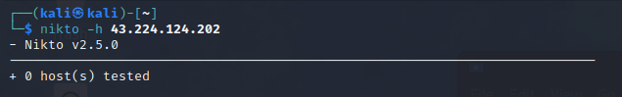

* **New tools**

**🡪** **rapid7**

A wide range of assets, including servers, network devices, databases, and web applications, may be scanned using this thorough scanning tool.

Vulnerability detection: By comparing the scanned systems to a database of known vulnerabilities, the scanner can find security defects such as software bugs, missing updates, default setups, weak passwords, and other flaws.

Risk assessment: Based on the severity, possible impact, and exploitability of vulnerabilities, the scanner rates them in terms of risk, enabling organisations to prioritise their remedial efforts.

Reporting and remediation advice: The programme creates reports that provide comprehensive details about vulnerabilities that have been found and offers advice on how to mitigate or resolve them.

Overall, the vulnerability scanner from Rapid7 assists businesses in proactively identifying and addressing security flaws in their systems, lowering the risk of assaults and enhancing overall security posture.

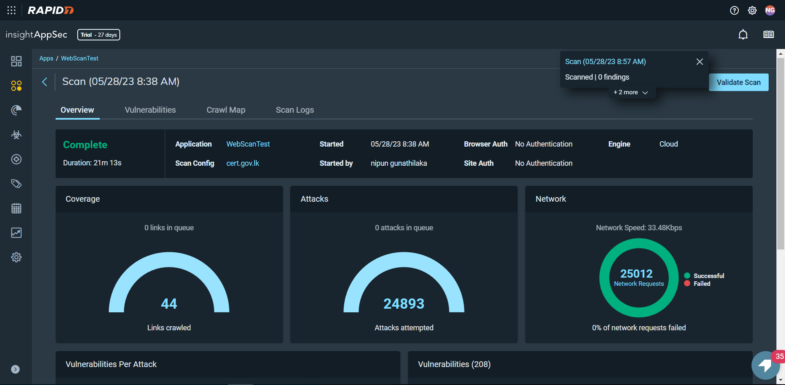

**Found Vulnerabilitys**

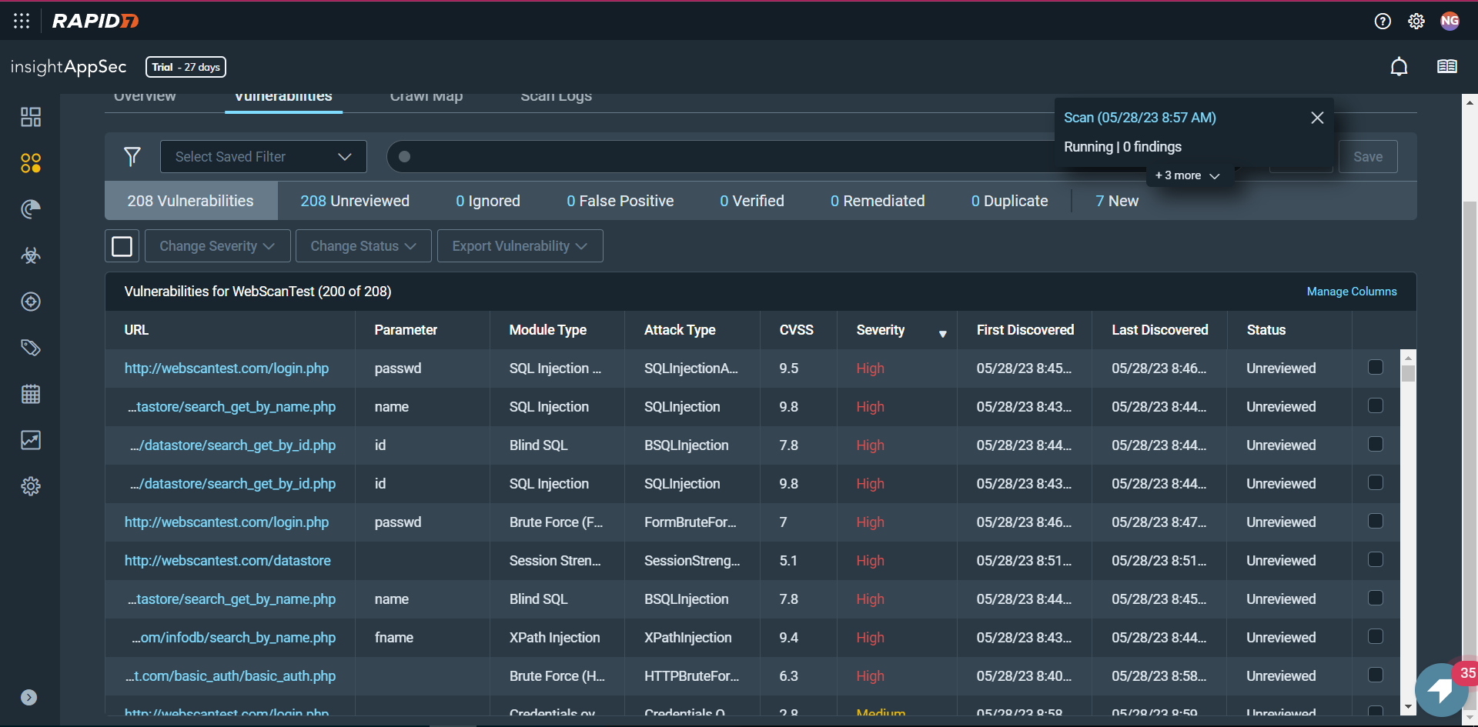

* **Techniques**

Nmap command:

sudo nmap -sV --script ssl-enum-ciphers 43.224.124.202

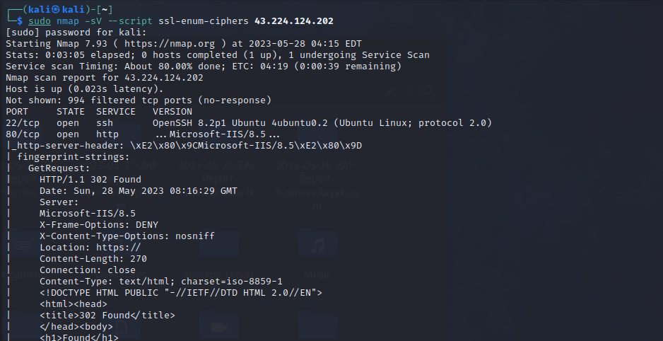

* **concepts learned**

When being communicated across the network, sensitive data must be safeguarded. User credentials and credit cards are examples of such information. As a general rule, if data has to be safeguarded while storage, it also needs to be protected during transmission.

Since HTTP is a clear-text protocol, HTTPS traffic results from HTTP traffic being routinely protected via an SSL/TLS tunnel. Utilising this protocol guarantees authentication as well as secrecy. Digital certificates are used to authenticate servers, and client certificates may also be used for mutual authentication.

Even while high-grade cyphers are supported and often used today, a server configuration error might compel the use of a poor cypher, or worse, no encryption at all, allowing an attacker to access the ostensibly secure communication channel. A Denial of Service attack may make use of further misconfiguration.

Clear-Text Transmission of Sensitive Data

Sensitive data shouldn't be sent by the application across unencrypted channels. Common HTTP requests for basic authentication, password input, session cookies, and other data deemed relevant by rules, legislation, or organisational policy can all be found.

Insecure SSL/TLS Cyphers, Protocols, and Keys

In the past, the U.S. government imposed restrictions on the export of cryptosystems, limiting key sizes to no more than 40 bits, a key length that may be cracked and enable communication decoding. Since then, restrictions for cryptography exports have been loosened; the maximum key size is now 128 bits.

It is crucial to examine the SSL configuration being used to prevent installing cryptographic support that may be quickly overthrown. SSL-based services shouldn't allow users to select a weak cypher suite in order to achieve this purpose. An encryption technique (such as DES, RC4, or AES), the length of the encryption key (such as 40, 56, or 128 bits), and the hash algorithm (such as SHA, MD5) used for integrity verification are the three components that make up a cypher suite.

The following are, in brief, the major considerations for determining the cypher suite:

In a ClientHello message, the client introduces itself to the server and includes details such as the protocol and cypher suites it supports. It should be noted that a client is often a web browser (currently the most popular SSL client), but this is not a requirement since it may be any SSL-enabled programme. Similarly, a server need not be a web server, although this is the most common scenario. (Consider also stun.)

The selected protocol and cypher suite for that session are included in the ServerHello message the server sends back in response. Typically, the server chooses the strongest protocol and cypher suite that is supported by both the client and server.

It is possible to select which cypher suites the server will honour (for instance, using configuration directives). You may decide whether or not communications with clients will only support 40-bit encryption in this manner.

If client authentication is necessary, the server additionally sends a CertificateRequest message to the client along with its Certificate message.

The server waits for a client response before sending a ServerHelloDone message.

The client checks the server's digital certificate's validity after receiving the ServerHelloDone message.

Validity of TLS/SSL Certificates - Client and Server

When using the HTTPS protocol to access a web application, a secure channel is created between the client and the server. Digital certificates are then used to establish the identities of either one (the server) or both (the client and server) parties. Therefore, the "SSL Handshake" continues with the exchange of the certificates after the cypher suite has been established:

If client authentication is necessary, the server additionally sends a CertificateRequest message to the client along with its Certificate message.

The server waits for a client response before sending a ServerHelloDone message.

The client checks the server's digital certificate's validity after receiving the ServerHelloDone message.

A number of tests on the certificates must be successful in order to start up the communication. Although it is outside the purview of this tutorial to address SSL and certificate-based authentication, this section will concentrate on the key factors involved in determining certificate validity:

determining if the Certificate Authority (CA) is well-known (i.e., one that is regarded as reliable);

confirming the certificate's continuing validity;

ensuring that the site's name and the name shown on the certificate are same.

Let's take a closer look at each check.

The certificate signing CA is checked against a pre-loaded list of trustworthy CAs that each browser ships with (this list may be altered and enlarged at will). If the server certificate belongs to a CA that the browser is not familiar with, a warning is often raised during the first talks with an HTTPS server. The main reason this occurs frequently is that a web application depends on a certificate that was signed by a self-created CA. The degree to which this warrants worry varies on a number of variables. For an intranet setting, for instance, where corporate online email is sent using HTTPS and if it is evident that all users trust the internal CA, this would be acceptable. However, when a service is made available to the general public over the Internet (i.e., when it is crucial to positively verify the identity of the server we are communicating with), it is typically essential to rely on a trusted CA, one that is acknowledged by the entire user base (and here we stop with our considerations; we won't go further into the implications of the trust model being used by digital certificates).

Certificates may expire because they have a specific duration of validity. Once more, the browser alerts us to this. A temporary certificate is required for a public service; otherwise, we would be communicating with a server whose certificate was issued by a third party that we trust but has since expired.

What happens if the server's name and the name on the certificate are different? It could seem suspicious if this occurs. This is not that uncommon to observe for a variety of reasons. Numerous name-based virtual hosts that share the same IP address and are identifiable by the HTTP 1.1 Host: header information may be hosted on a single system. It is not possible to provide multiple certificates to each virtual server in this scenario because the SSL handshake verifies the server certificate before processing the HTTP request. We therefore have a condition that is normally shown by the browser if the name of the site and the name stated in the certificate do not match. IP-based virtual servers must be utilised to prevent this. Techniques to solve this issue and allow name-based virtual hosts to be appropriately addressed are described in sslyze and RFC: TLS Extensions.

There are further flaws

If the programme is out-of-date, the existence of a new service listening on a different tcp port may present vulnerabilities like infrastructure vulnerabilities. Additionally, the Session Cookie has to have the Secure flag set, and certain directives should be given to the browser telling it to only allow secure communications (such HSTS, CSP).

If the web server exposes the application via HTTP and HTTPS, or if HTTP and HTTPS resources are combined together on the same page, there are several methods that may be used to intercept traffic.

* **Reflections and takeaways**

The necessity of utilising powerful cryptographic algorithms and cyphers to guarantee the secrecy, integrity, and validity of sensitive data is highlighted.

Regular vulnerability assessments: To find any weak cyphers or other security flaws in their systems, organisations should regularly undertake vulnerability scans and assessments.

Patching and upgrading are essential for preventing vulnerabilities brought on by weak cyphers. This includes keeping systems, programmes, and cryptographic libraries up to date. It makes sure that fixes and upgrades are applied to address known security issues and shortcomings.

Best practises for configuration: To eliminate weak cyphers and mandate the use of strong cryptographic algorithms, it is crucial to configure encryption settings and protocols correctly. Following security best practises and industry standards reduces the possibility of weak cypher vulnerabilities.

Continuous surveillance and defence: A strong security posture requires constant surveillance of systems and networks for possible flaws, such as weak cyphers. Putting intrusion detection and prevention systems in place can assist in spotting and thwarting any attempts to take advantage of weak cypher weaknesses.

**15th May 2023**

**Summary of the day's activities**

Using SqlMap, Nmap, zap, and any other tools to search the website and find high-level vulnerabilities. Pll vulnerability identification.

**Vulnerabilities discovered or explored**

* Information gathering

🡪 HackerOne guidelines

URL: [https://www.xvideos.com](https://www.xvideos.com/)

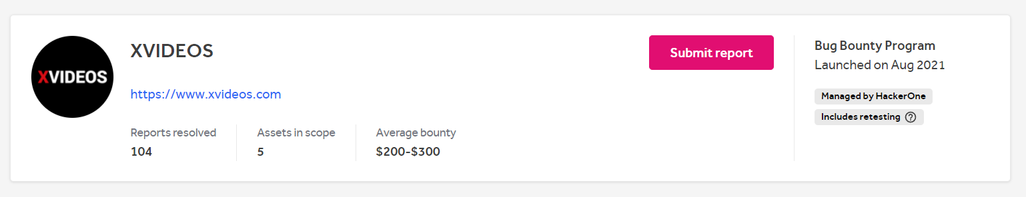

**Policy**

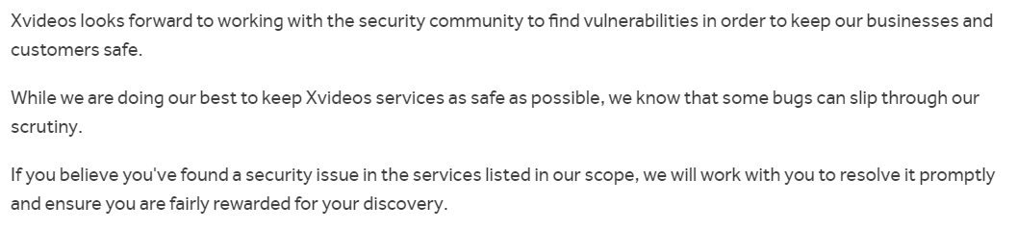

**Scope**

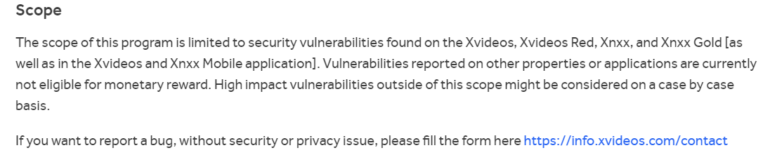

**Eligible Vulnerabilities**

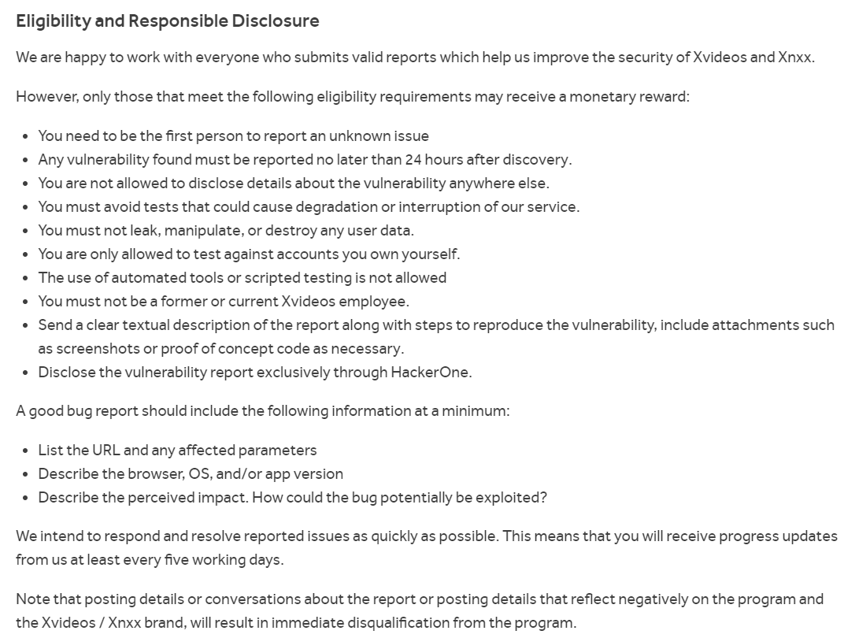

**Non-Qualifying Vulnerabilities and Exclusions**

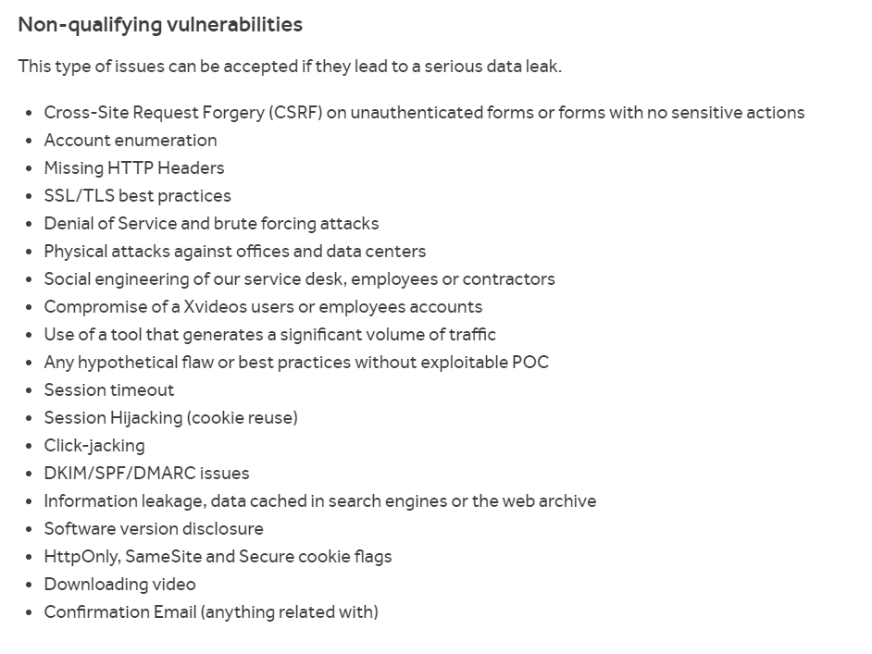

**Scope**

* In Scope

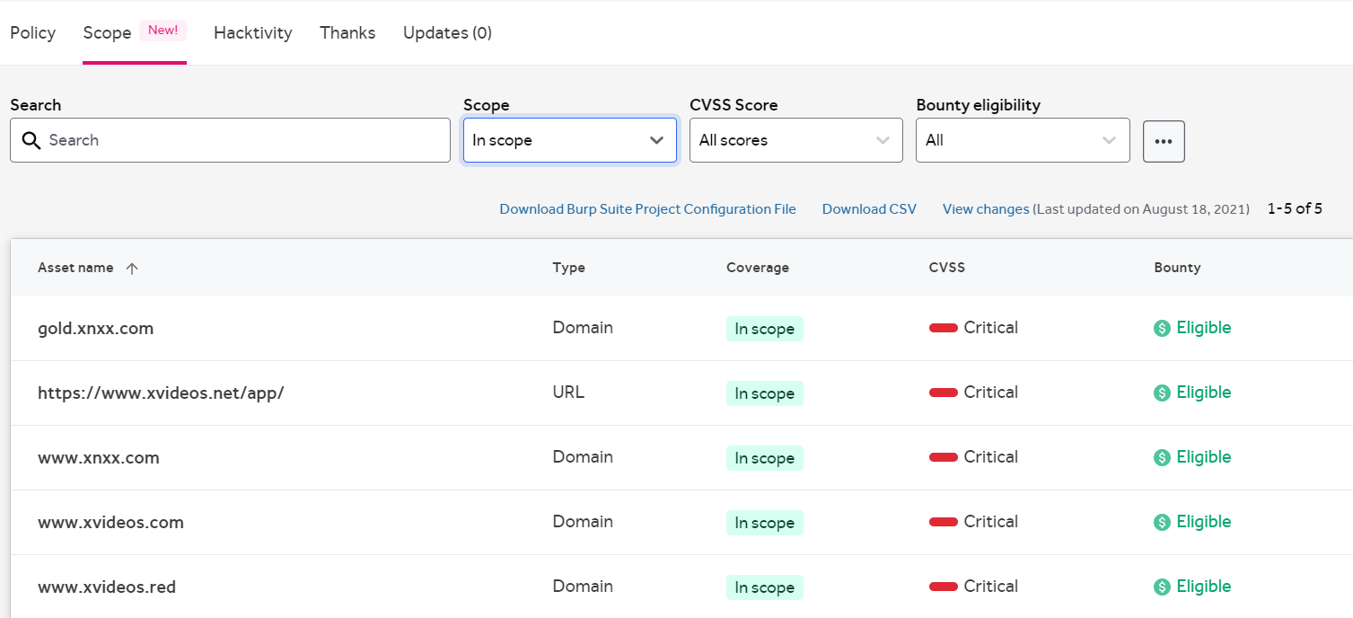

* Out Scope

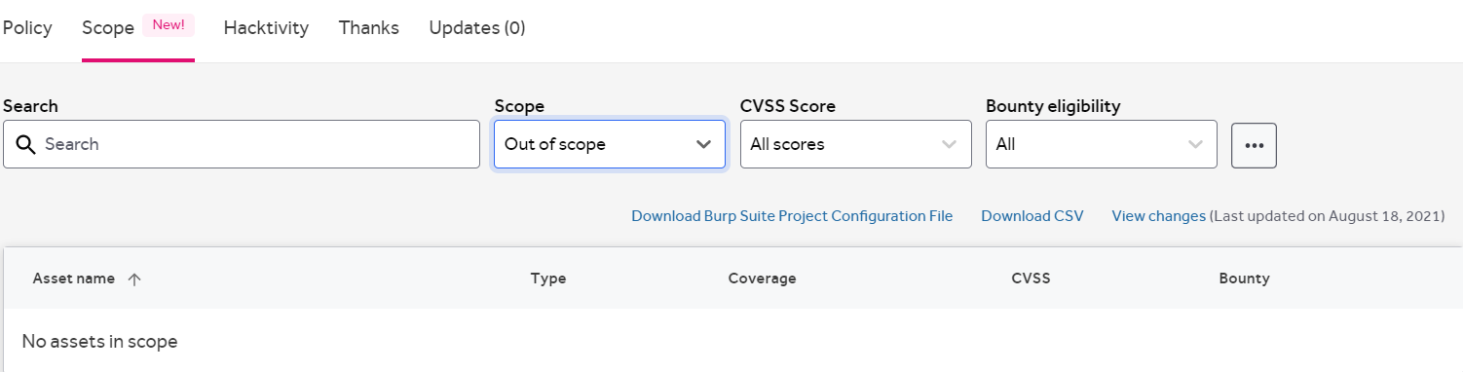

🡪 **About the website**

. 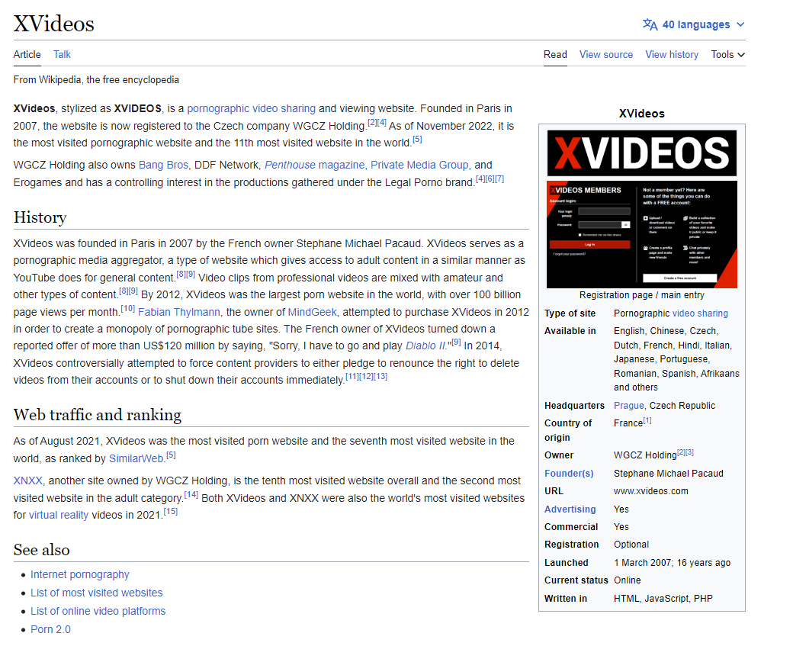

* + About the Sub Domain that are discovered ( **www.xnxx.com** )

Introduction:

It is video platform of the main domain and it contain more different video

**Challenges faced and how they were overcome**

First, I use the my device Ip address for information gathering , but most of time my Ip address was blocked . so, I use the VPN to gather the information about the website.

challenging to visit the webpage

Taken more time than expected.

* **New tools**
  + Sqlmap

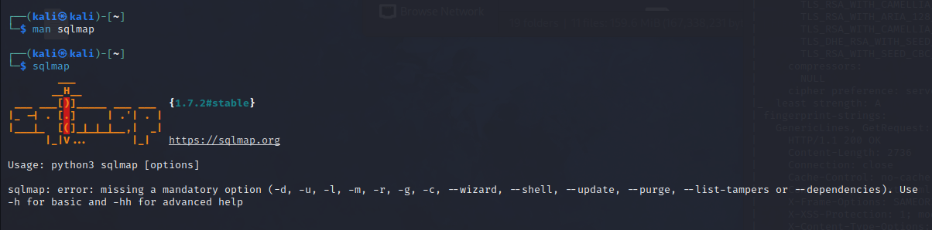

Sqlmap is a very flexible intelligent fuzzer to discover personality identifiable information Disclosure vulnerabilities. in this tool use to retrieve the private information about website such and bank details , admin information etc.

in the domain or sub domain I couldn’t find any pll disclosure vulnerability.but I try the several command to find any ppl in the domain bot my try was vanish.so now I know several commands about sqlmap and how thay are worked.

**Command:** sqlmap -u https://testsite.com/page.php?id=1 -D <db_name> -tables

* **Techniques**

**OWASP ZAP**

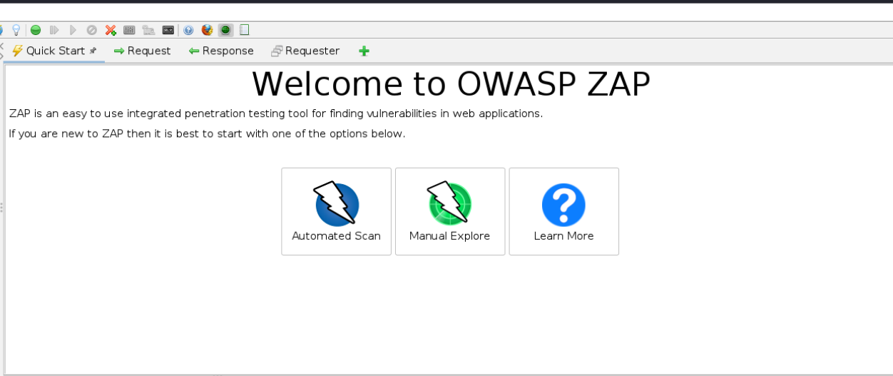

This is the powerful tool and when I scan my subdomain inside the ZAP, I can found the pll disclosure vulnerbility.

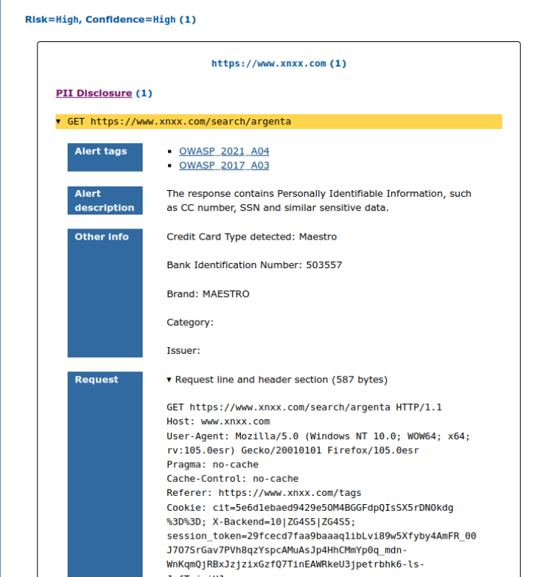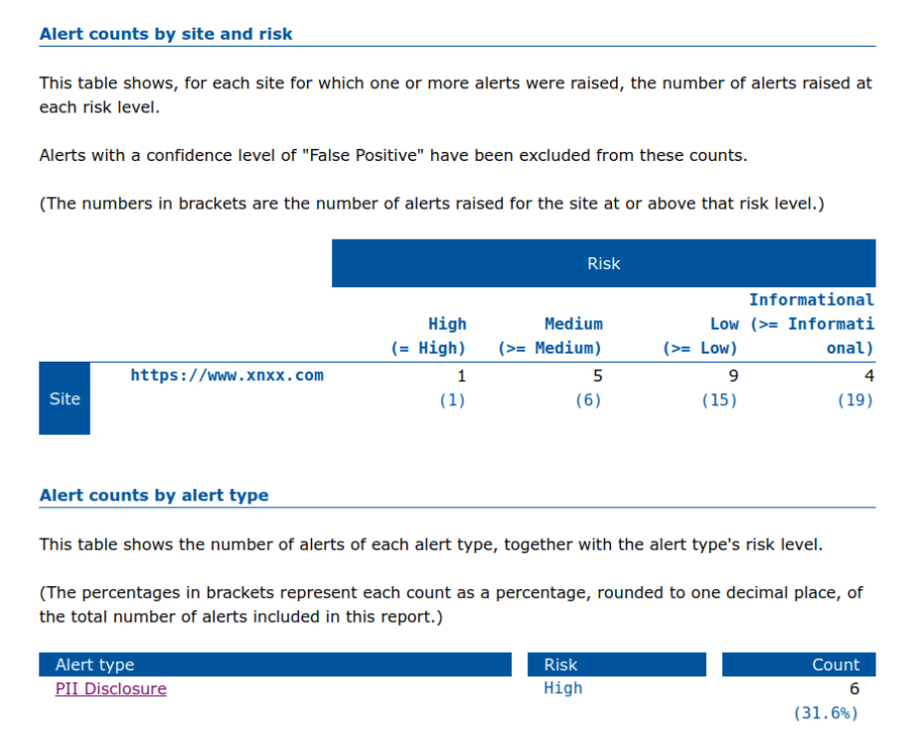

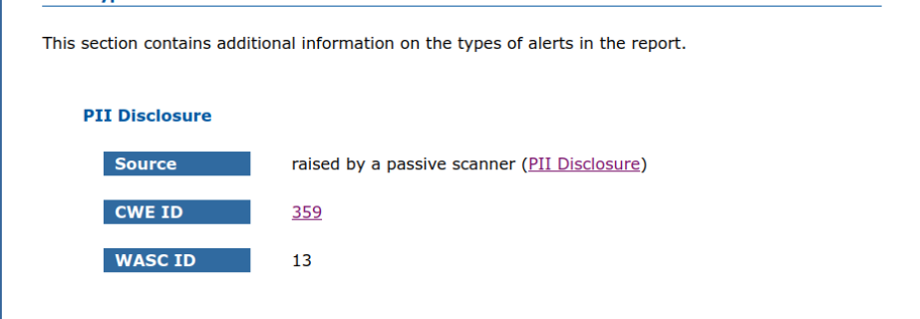

For this website pll is high level vulnerbility and confidence level is high.

So, I spend the 10 min to scan this output. I use the automatic scan with the firebox header attack.

* **concepts learned**

**PII (Personally Identifiable Information) Disclosure**

# [According to Common Weakness Enumeration website](https://cwe.mitre.org/index.html)

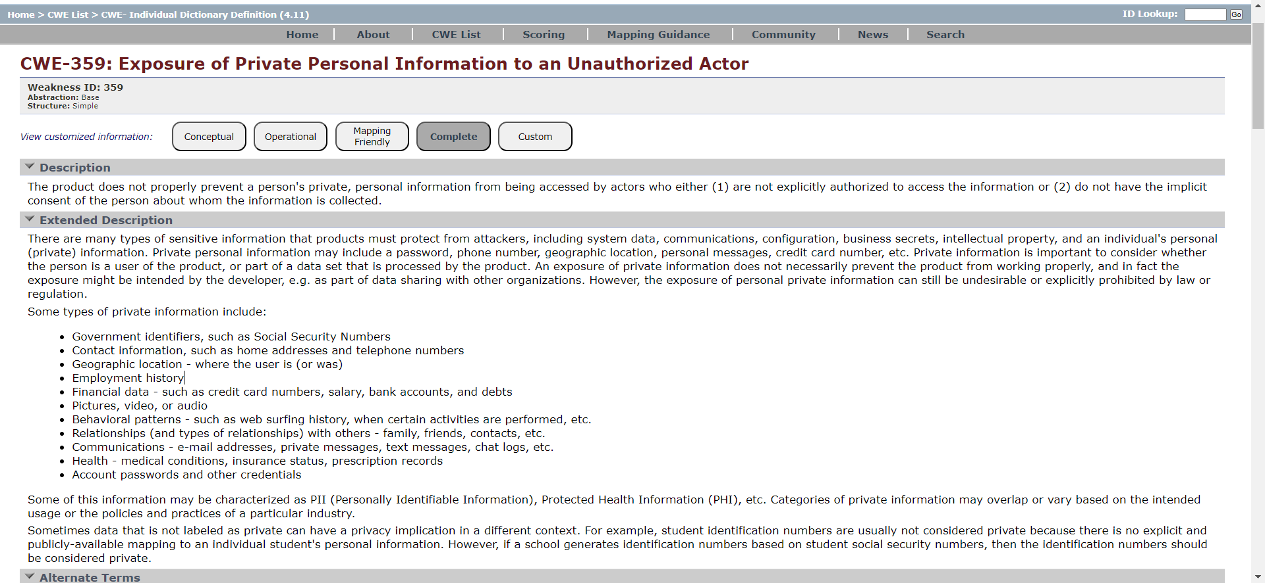

Example 1 code :-

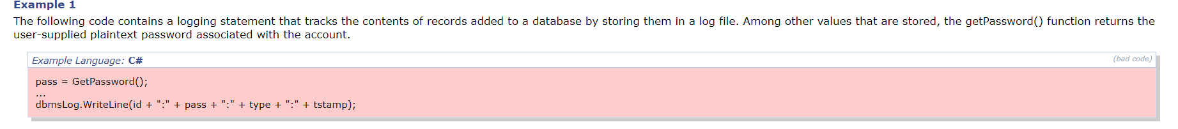

Example 2 code :-

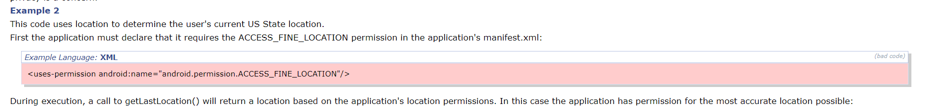



**Reflections and takeaways**

Leaks of personally identifiable information (PII) can have detrimental impacts on both individuals and organizations. Here are some ideas and lessons regarding the dangers of disclosing PII:

Data protection is crucial because personally identifiable information (PII) can contribute to identity theft, financial fraud, and other privacy violations if it is shared. If a company wants to maintain customer trust and adhere to privacy rules, protecting PII should be their first priority.

Secure Data Handling: You require robust security measures, such as encryption, access controls, and safekeeping, to handle personally identifiable information (PII) properly. Strong security procedures reduce the likelihood that private data may be accessed or shared without authorization.

Utilizing a data minimization strategy can assist reduce the potential harm that could be caused by PII exposure issues. Ensure that only the PII required for legal purposes is collected and retained, and that the proper procedures are followed to securely delete or anonymize data when it is no longer required.

agreement and Transparency: Obtain someone's explicit and informed consent before collecting their PII. Explain to them in detail how their data will be used, saved, and protected. People's trust is increased and they are given the knowledge they need to make an informed decision about sharing their data.

Regularly conducting audits and assessments will help you identify any flaws or gaps in the security of your PII. Establish robust tracking systems to catch anybody attempting to enter without authorization or acting strangely that could indicate a PII leak issue.

Employee Education: Inform staff members on the significance of safeguarding PII and provide them with instruction on the best ways to manage data, security precautions, and privacy laws. A stronger defense against PII exposure vulnerabilities is having employees with power and expertise.

Compliance with Privacy Laws: Be aware of the privacy laws that concern you, such as the California Consumer Privacy Act (CCPA) or the General Data Protection Regulation (GDPR). Make sure you're abiding by the law to safeguard individuals' PII and lower the likelihood that you'll face penalties for failing to do so.

Set up an incident response plan to deal with PII leaks rapidly. Response to an Incident and Communication. Reducing the impact, maintaining confidence, and adhering to legal requirements all depend on effective communication with those who may be impacted and other significant parties.

In general, PII protection requires a thorough strategy that incorporates technology tools, policy, personnel training, and abiding with privacy regulations. Organizations can lower the danger of PII leaks and safeguard people's right to privacy by prioritizing data security.

**28th May 2023**

**Summary of the day's activities**

**Path Traversal** vulnerability identification utilizing Nmap zap and any other tools to explore the website and locate high-level vulnerabilities.

**Vulnerabilities discovered or explored**

* Information gathering

🡪 HackerOne guide lines

URL: <https://www.kayak.com/>

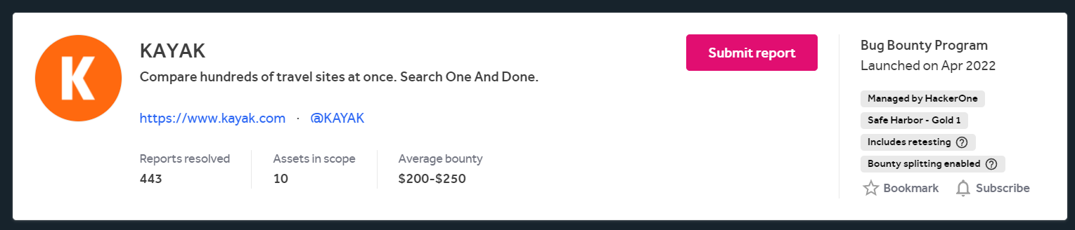

**Policy**

KAYAK is committed to working with security experts across the world to stay up to date with the latest security techniques. If you have discovered a security issue that you believe we should know about, we'd welcome working with you.

**Scope**

Scope is outlined in the structured scope section. Please do not submit the same report for multiple domains. Only one report will be accepted.

**Eligible Vulnerabilities**

* You must be the first person to report a vulnerability.
* Please share with us the full details of any problem you find.
* The vulnerability must be on an in-scope site or application.
* Qualification of vulnerabilities is at the sole discretion of the KAYAK security team.
* The vulnerability must be reproducible on a reasonably recent version of the according client (e.g., at least Microsoft Edge, Chrome 111, Firefox 111, Safari 15)
* Vulnerabilities raised on the Android or iOS apps must be against the latest app store versions

**Non-Qualifying Vulnerabilities and Exclusions**

* **Clarification - NEW** We do not take any responsibility for links to third-party/off-site content including social media profiles that may have been owned by us previously or be trying to impersonate us. This includes any links you find on our assets in all areas of the products including headers and footers.
* Denial of service, distributed denial of service, or other availability attacks.
* Any techniques related to web scraping
* Brute force attacks against passwords, hash secrets etc.
* Physical attacks against any KAYAK office or data center.
* Social engineering, for example phishing or calling, of any KAYAK employee, contractor or agent.
* One of the following issues without a proof-of-concept that successfully exploits the issue:
  + SSL configuration
  + HTTP response headers including cookie configuration
* Logout CSRF and CSRF on endpoints that do not change user state. MITM attacks against a user's CSRF token.
* Issues with any site or application not explicitly listed as in-scope.
* Problems found in our iOS apps before v205 and Android apps before v175
* Issues introduced by third-party components that have not been fixed by the vendor yet. This also includes vulnerabilities introduced by content served through one of our ad networks.
* Third-party content served on HTTP when KAYAK is accessed on HTTPS. Particularly with ad networks we have no direct control.
* Clickjacking (except rare, highly sensitive cases)
* Attacks that require a mobile phone or tablet to be "rooted". Attacks that assume that a user intentionally or unintentionally disabled standard OS security features.
* Absence of SPF, DKIM, DMARC or domain lock records
* DNSSEC-related reports
* Lack of "best practices" that do not impose a vulnerability that can be leveraged (please send PoC)
* Missing or not obviously visible rate limiting - please do not test our endpoints for this as this makes noise that we usually pick up and act on
* Vulnerabilities in third-party software and systems that we use. We are patching components on a regular basis according to our risk assessments.
* Vulnerable domain/DNS configuration are only in scope as long as they involve our core assets as listed in this program. For example, a domain takeover of some-service.kayak.com is a valid finding while a domain takeover of any other domain owned by us but not part of our core assets is not.
* We cannot reward or do business with any individual on any U.S sanction lists or any individual residing in any country on any U.S. sanctions lists. This includes residents of Cuba, Sudan, North Korea, Iran, Syria or Russia.
* Severity level is at the sole discretion of the KAYAK security team.

**Rules of Engagement**

* Use a custom HTTP header and mention that in your report. For example, a header that includes your username: X-Bug-Bounty:HackerOne-your-username.
* When making an account or reservation, please use your HackerOne Email Alias (e.g., [username@wearehackerone.com](mailto:username@wearehackerone.com)), so that we can properly identify you
* Do not compromise any customer accounts or data. Never attempt to view, modify, or damage data belonging to others. If you need to test a vulnerability, create an account.
* Do not use automated tools that could generate significant traffic and possibly impair the functioning of our services.
* Do not discuss or post details of your vulnerability outside of the HackerOne platform before it has been approved for disclosure.
* Do not attempt denial-of-service attacks. **Keep your automated scanning to 10 requests per second or less.**
* Please communicate with our security team via HackerOne.
* We may change the terms of this program at any time.

For any bugs pertaining to Information Disclosure, please do not capture and retain any personally identifiable or sensitive personal information (PII) during the course of your research. If you inadvertently view or change any PII not related to your own account, please stop testing immediately and submit a report with reproduction steps so that our team can evaluate the potential business impact of any exposed PII.

When possible, please employ methods that confirm elevated access without exposing PII, for example:

* Screenshots of navigation bar options or pages without PII that weren’t originally viewable.
* Improper access to another account you yourself control
* (in the case of gaining access to a company server) Access to common default files present on any server

**Attributes of a Good Report and Bug Bounty Rewards**

* Please provide a detailed report with precise explanations. Please include screenshots, proof-of-concept code, and steps to reproduce.
* Bug bounty rewards are solely at KAYAK's discretion, based on the severity and creativity of the bug.
* You must adhere to HackerOne's Disclosure Guidelines and everything outlined in this policy. We are committed to ensuring the privacy and safety of our users. If you think that you have discovered a security vulnerability on our web site or within our mobile apps we appreciate your help in disclosing the issue to us. Please do this responsibly by giving us the opportunity to investigate and fix the vulnerability in a timely fashion before publicly disclosing it. Security vulnerability reports will be treated as high priority. We will validate and fix vulnerabilities in accordance with our commitment to security and privacy.

**Scope**

* In Scope

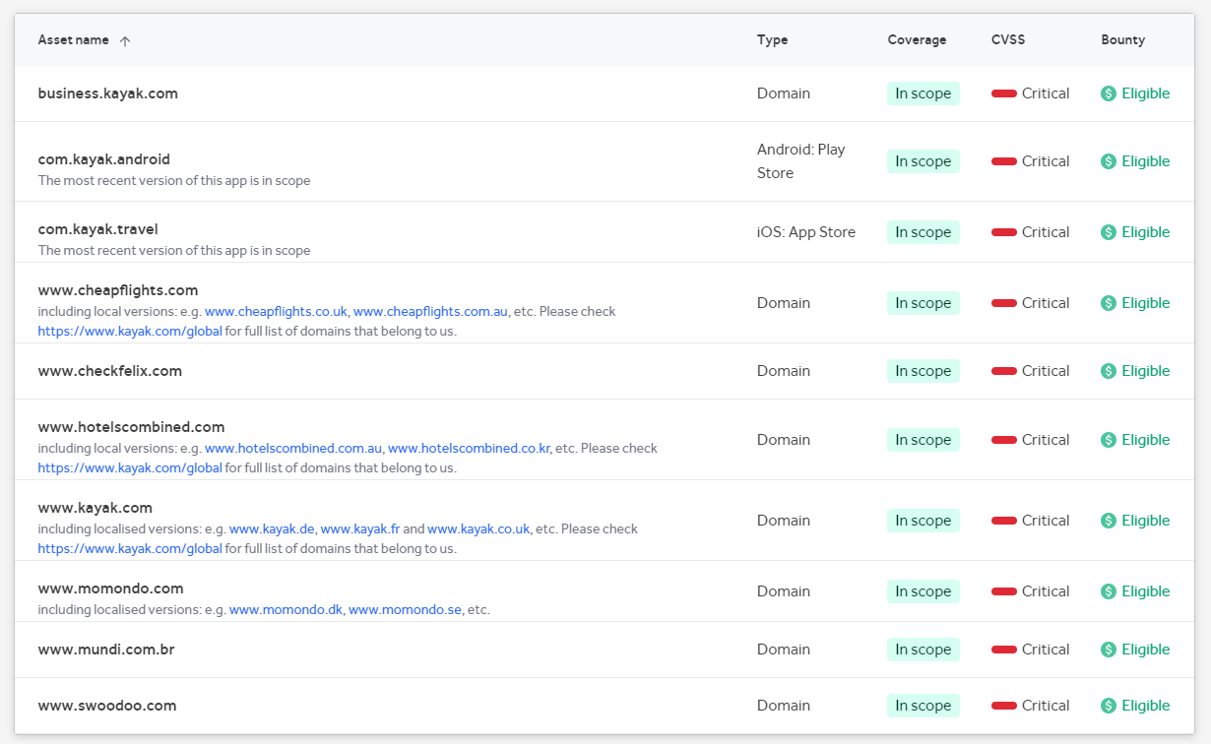

* Out Scope

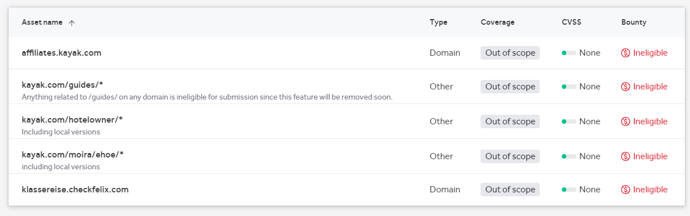

🡪 **About the website**

Flight Search: Users can search for flights on Kayak.com by entering the airports they want to fly into and out of, the dates they want to travel, and the number of people. It includes both one-way and round-trip ticket options, as well as filters to narrow down search results based on particular factors like airlines, pricing ranges, departure times, and layovers.

User can search for hotels by entering their destination, arrival and departure dates, and the total number of guests. According to preferences such star rating, amenities, guest reviews, and price range, Kayak.com offers a broad variety of filters to reduce the number of search results.

Using their pick-up and drop-off locations, dates, and hours, consumers may search for and compare vehicle rental choices on Kayak.com. It provides filters for automobile type, rental company, and price range to assist consumers in finding the best possibilities.

Vacation Packages: Users can look for vacation packages on the website, which include bookings for hotels, flights, and rental cars. When opposed to making separate reservations for each element, these packages can frequently result in cost savings.

Price Tracking and Alerts: Kayak.com has a price tracking service that enables users to keep track of changes in airfare, hotel rates, and rental car prices. For notifications when the costs for particular searches go down or up, users can set up price alerts.

Explore and Discover: Kayak.com offers tools and services to assist customers in discovering new locations, viewing popular travel locations, and exploring locations that are trending based on numerous criteria such as the time of year, budget, and activities.

* + About the Sub Domain that are discovered ( **business.kayak.com** )

Users of the well-liked online travel agency and metasearch tool Kayak business can compare costs for lodging, transportation, and other travel-related services. The website compiles information from numerous sources and gives customers a thorough rundown of all available possibilities, enabling them to make well-informed choices when making travel reservations.

Introduction:

Briefly describe Kayak and its function as a metasearch engine and online travel agent.

Functions and characteristics:

Talk about Kayak's key attributes and advantages, such as its ability to search for flights, hotels, rental cars, vacation packages, and other travel-related services.

Describe how Kayak combines information from several sources and displays it in a logical manner.

Mention any special options or features that Kayak offers, such as price alerts, flexible date search, and explore.

User Interface:

Describe the Kayak website's user experience, including the design, search choices, and sorting options.

Talk about the website's usability and accessibility for users.

Mention any mobile platforms or applications that Kayak provides to users to access its services.

Making a reservation:

Describe the Kayak booking process, including how consumers can pick and contrast various alternatives, view rates, and complete the booking.

In order to complete bookings, discuss any integration with third-party providers or travel agencies.

Customer Service

Describe the customer service channels offered on Kayak, such as live chat, email help, FAQs, and phone assistance.

Security and Confidentiality

Talk about Kayak's privacy and security policies, including any steps taken to safeguard customer information and guarantee secure transactions.

business strategy

Describe Kayak's business model, which often entails receiving commissions or referral fees from affiliated travel suppliers when customers make reservations on the website.

Talk about any other collaborations or revenue sources Kayak might have, such as any advertising or sponsored listings.

Competitive Environment:

Mention a few of the key rivals or comparable websites in the online travel agency and metasearch market briefly.

Highlight any special features or benefits that set Kayak apart from its rivals.

**Challenges faced and how they were overcome**

Challenging to visit the webpage

That website restricted my IP address and then I use a VPN for resolve that problem.

Taken more time than expected for scanning .

* **New tools**
  + Dotdotpwn

DotDotPwn is a very flexible intelligent fuzzer to discover traversal directory vulnerabilities in software such as HTTP/FTP/TFTP servers, Web platforms such as CMSs, ERPs, Blogs, etc.

**Command:**

dotdotpwn.pl -m http -h 199.232.81.29 -M GET

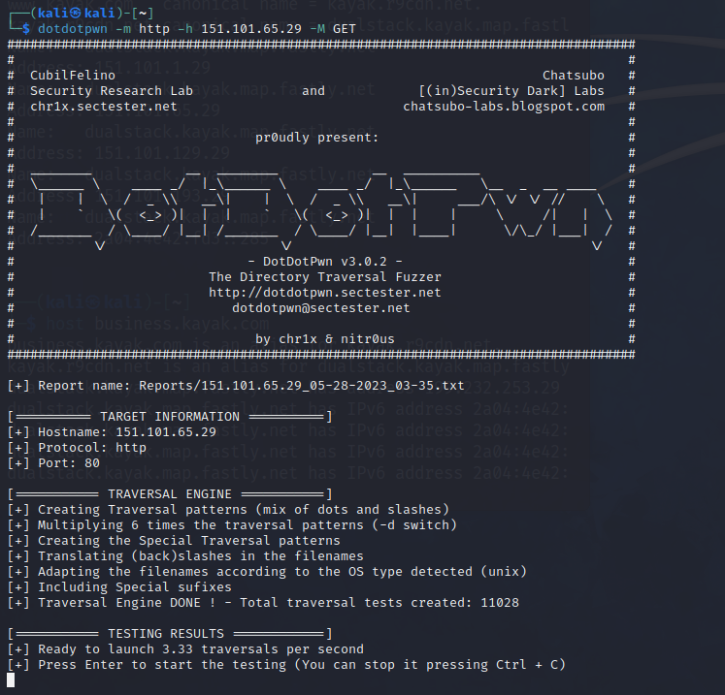

* **Techniques**

Nmap command:

nmap --script http-tplink-dir-traversal.nse --script-args rfile=/etc/topology.conf -d -n -Pn 151.101.65.29

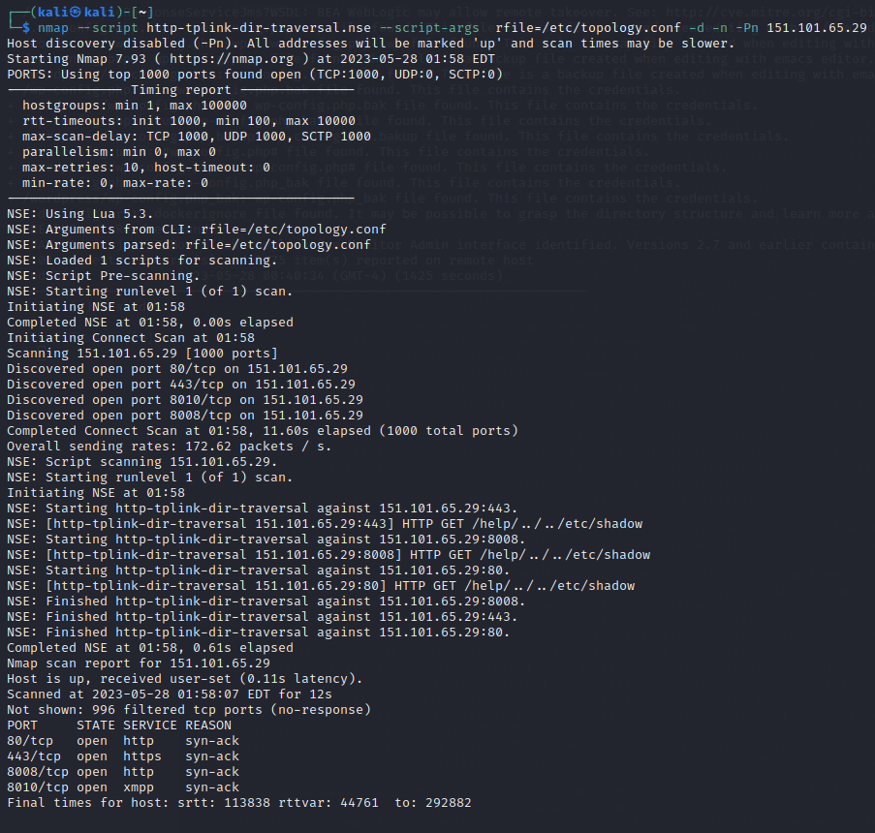

**Nikto -h 151.101.65.29**

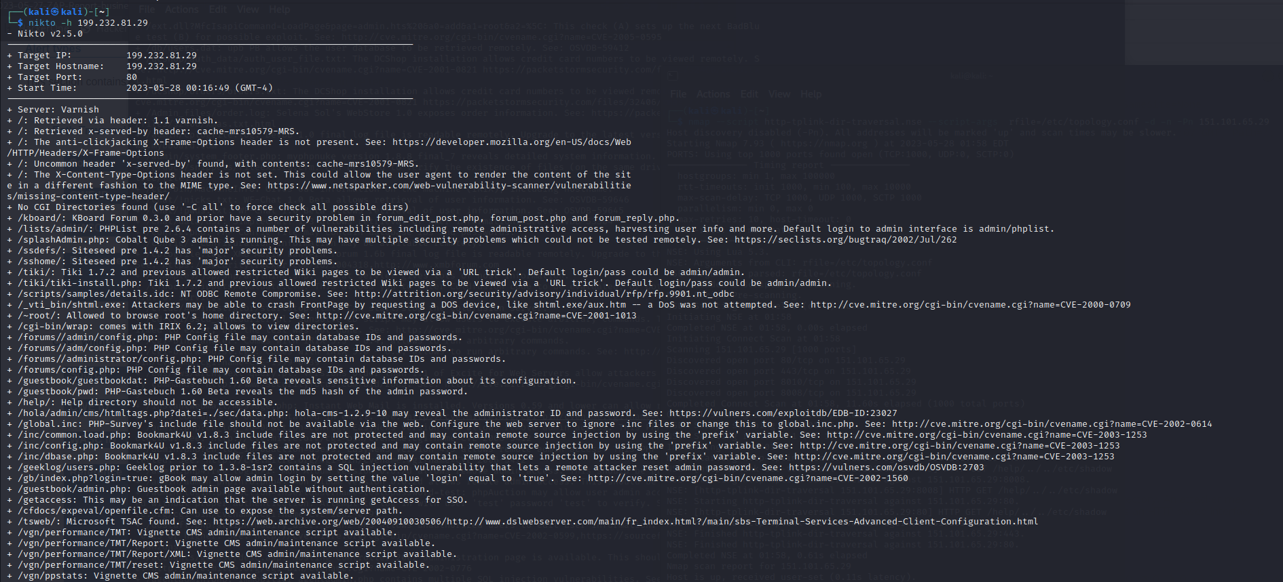

* **concepts learned**

# Path Traversal

The Path Traversal attack technique allows an attacker access to files, directories, and commands that potentially reside outside the web document root directory. An attacker may manipulate a URL in such a way that the web site will execute or reveal the contents of arbitrary files anywhere on the web server. Any device that exposes an HTTP-based interface is potentially vulnerable to Path Traversal.

Most web sites restrict user access to a specific portion of the file-system, typically called the "web document root" or "CGI root" directory. These directories contain the files intended for user access and the executable necessary to drive web application functionality. To access files or execute commands anywhere on the file-system, Path Traversal attacks will utilize the ability of special-characters sequences.

The most basic Path Traversal attack uses the "../" special-character sequence to alter the resource location requested in the URL. Although most popular web servers will prevent this technique from escaping the web document root, alternate encodings of the "../" sequence may help bypass the security filters. These method variations include valid and invalid Unicode-encoding ("..%u2216" or "..%c0%af") of the forward slash character, backslash characters ("..\") on Windows-based servers, URL encoded characters "%2e%2e%2f"), and double URL encoding ("..%255c") of the backslash character.

Even if the web server properly restricts Path Traversal attempts in the URL path, a web application itself may still be vulnerable due to improper handling of user-supplied input. This is a common problem of web applications that use template mechanisms or load static text from files. In variations of the attack, the original URL parameter value is substituted with the file name of one of the web application's dynamic scripts. Consequently, the results can reveal source code because the file is interpreted as text instead of an executable script. These techniques often employ additional special characters such as the dot (".") to reveal the listing of the current working directory, or "%00" NULL characters in order to bypass rudimentary file extension checks.

### Example

Path Traversal attacks against a web server

http://example/../../../../../etc/passwd

http://example/..%255c..%255c..%255cboot.ini

http://example/..%u2216..%u2216someother/file

Path Traversal attacks against a web application

Original: http://example/foo.cgi?home=index.htm

Attack: http://example/foo.cgi?home=foo.cgi

In the above example, the web application reveals the source code of the foo.cgi file because the value of the home variable was used as content. Notice that in this case the attacker does not need to submit any invalid characters or any path traversal characters for the attack to succeed. The attacker has targeted another file in the same directory as index.htm.

Path Traversal attacks against a web application using special-character sequences:

Original: http://example/scripts/foo.cgi?page=menu.txt

Attack: http://example/scripts/foo.cgi?page=../scripts/foo.cgi%00txt

In above example, the web application reveals the source code of the foo.cgi file by using special-characters sequences. The "../" sequence was used to traverse one directory above the current and enter the /scripts directory. The "%00" sequence was used both to bypass file extension check and snip off the extension when the file was read in.

**Reflections and takeaways**

Improved grasp of Path Traversal Vulnerabilities: By actively looking for path traversal vulnerabilities, you develop a better grasp of how these flaws occur and the various approaches used to exploit them. This understanding will enable you to better safeguard systems and applications against such vulnerabilities in the future.

Input Validation and Sanitization: Path traversal vulnerabilities are frequently caused by insufficient input validation and sanitization. Participating in bug bounty programmes emphasises the importance of developing effective input validation procedures to prevent fraudulent user input from modifying file paths.

Context and Relative Paths Awareness: Path traversal vulnerabilities rely significantly on an understanding of the application's context and relative file paths. Participating in bug bounty programmes helps you hone your skills in analysing context and detecting potential application traversal points.

Real-World Application of Security Best Practises: Bug bounty programmes allow you to put security best practises, such as secure code, secure file handling, and correct access controls, into action. This hands-on experience reinforces the need of putting these practises into action in real-world circumstances.

Collaboration and Communication Skills: Interaction with the organisation running the programme is common in bug bounty programmes. Successful vulnerability reporting and mitigation requires effective communication and collaboration with the organization's security team. Participating in these programmes improves your communication and teamwork abilities.

Participation in bug bounty programmes promotes ongoing learning and adaptability. You must stay up to date on new tactics and defences and change your testing methodologies accordingly. This continuous learning process is critical for retaining effectiveness in detecting path traversal vulnerabilities.

Impact of Responsible Disclosure: Bug bounty programmes emphasise the importance of reporting vulnerabilities to the organisation in a responsible manner. Understanding the impact of responsible disclosure and the appropriate channels for disclosing vulnerabilities contributes to the development of a responsible disclosure culture and creates beneficial relationships between security researchers and organisations.

Ethical and Professional Conduct: Participating in bug bounty programmes necessitates adherence to ethical and professional principles. It emphasises the significance of operating responsibly, keeping integrity, and adhering to the organization's policies and procedures.

Developing a Reputation and Professional Network: Successfully detecting and disclosing route traversal vulnerabilities can help you establish a reputation as a knowledgeable security researcher. It may also provide opportunities for collaboration, networking, and professional development within the security field.

Contributing to Overall Security: Bug bounty programmes play an important role in enhancing organisations' overall security posture. You can help to improve the security of systems and applications used by a wide range of users by actively engaging in these programmes and responsibly reporting vulnerabilities**.**

**20th April 2023**

**Summary of the day's activities**

**Out-of-date version** vulnerability identification utilizing netsparker and any other tools to explore the website and locate mid-level vulnerabilities.

**Vulnerabilities discovered or explored**

* Information gathering

🡪 hackerOne guidelines

URL: [vcahospitals.com](https://www.8x8.com)

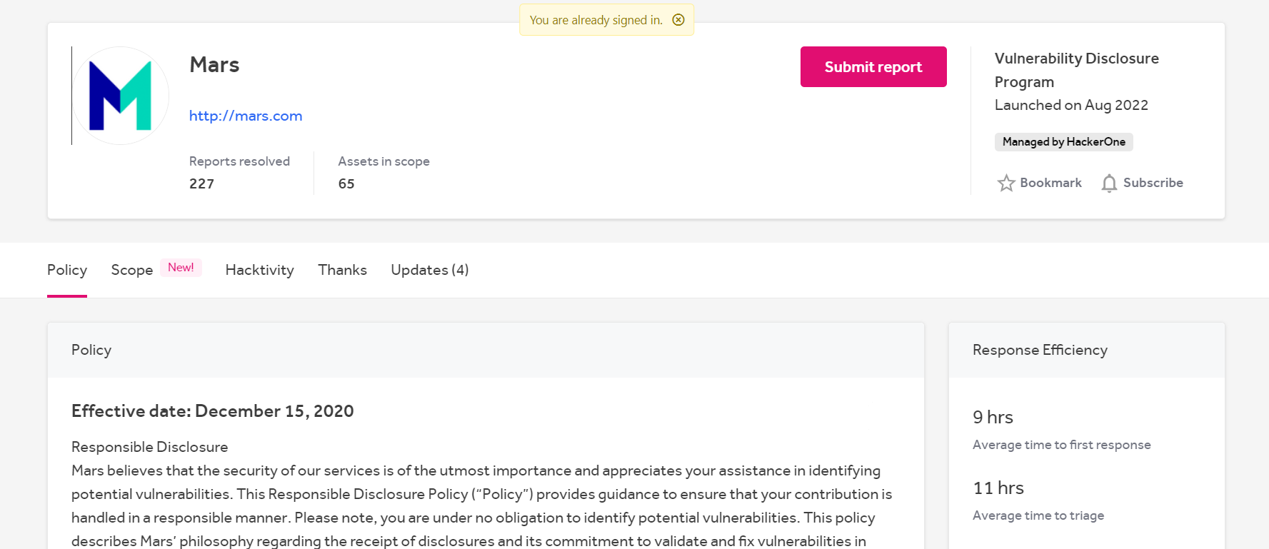

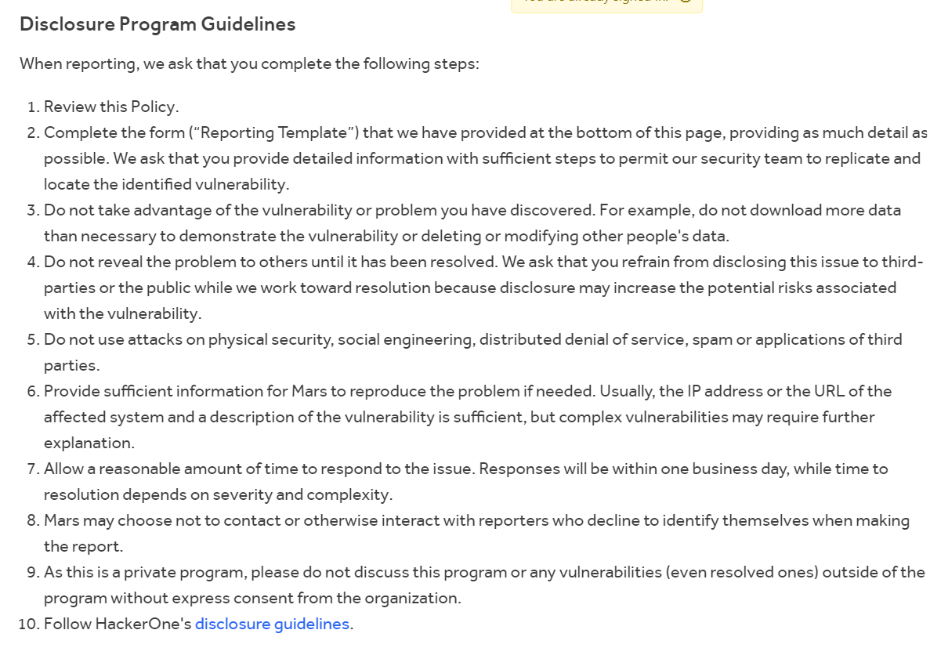

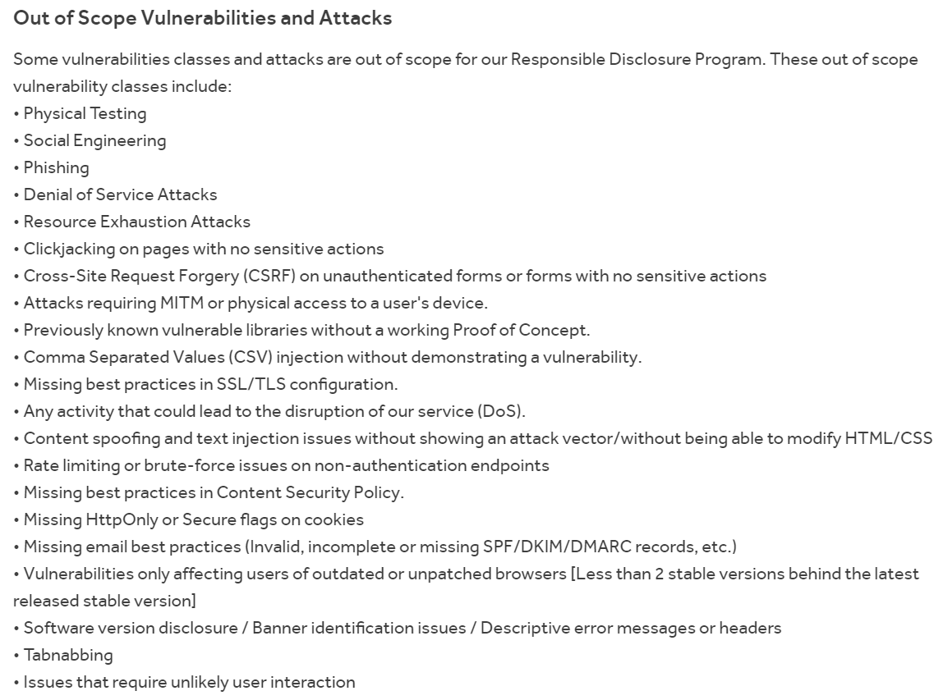

In scope

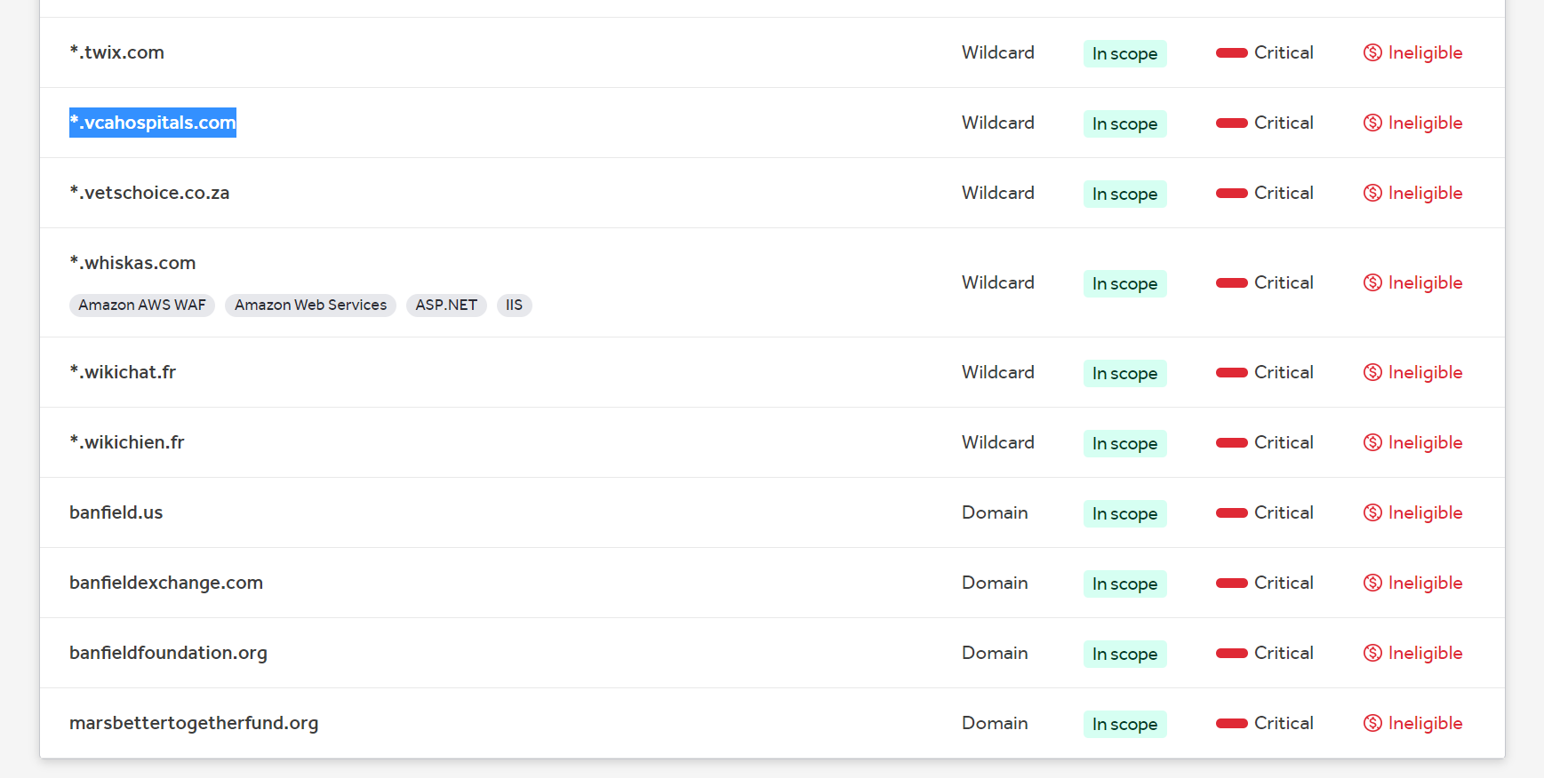

Out of scope

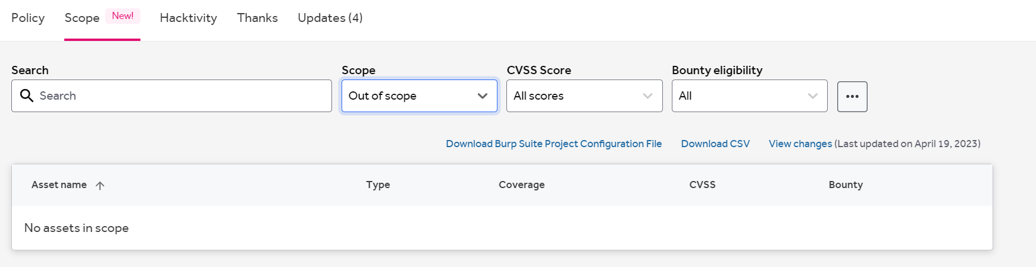

🡪 **About the website**

Mars, Inc. is a global company that makes well-known brands in the food, candy, and pet care fields. The company makes a wide range of things, like sweets, candies, snacks, pet food, and other market goods. Mars, Inc. does business in many different countries and has many well-known names, such as M&M's, Snickers, Milky Way, Skittles, Pedigree, Whiskas, and many more.

If you're talking about a different website with the URL "http://mars.com," please give me more information about the organization or goal of that site so I can help you better.

**Challenges faced and how they were overcome**

First, I use my device Ip address for information gathering , but most of time my Ip address was blocked . so, I use the VPN to gather the information about the website.

challenging to visit the webpage

Taken more time than expected.

* **New tools**

**🡪** **nmap tool**

The well-known open-source program Nmap, which stands for "Network Mapper," is used to examine and rate the security of computer networks. In addition to its primary purpose, which is to locate hosts and services on a computer network, it is intended to carry out a number of tasks connected to network exploration and security assessment. Here is a summary of some significant traits and abilities that Nmap possesses:

The technique of probing a target host or network to determine which ports are open, closed, or filtered is known as port scanning, and Nmap is widely used for this task. It can help with the detection of potential points of entry and vulnerabilities in network systems.

Host Discovery: Nmap's host discovery capability can be used to determine whether hosts on a network are currently functioning by sending ICMP echo queries (pings) or by using other techniques.

Nmap can gather data about services that are active on target systems and attempt to ascertain the versions of those services. With the help of this data, it will be simpler to spot services that are vulnerable to assaults and set up the necessary security measures.

Name of the Operating System In order to determine the active operating systems on target computers, Nmap can analyze network responses. It helps to become aware of the network environment and any potential vulnerabilities that may be particular to each operating system thanks to this functionality.

The NSE (Nmap Scripting Engine), a powerful scripting engine built into Nmap, enables users to create and run scripts for more sophisticated network discovery, vulnerability identification, and exploitation. NSE (Nmap Scripting Engine) is the name of Nmap's powerful scripting engine.

Network Mapping and Visualization: Nmap provides the capacity to produce network maps and visualizations that show the architecture and design of a network. This makes it easier to comprehend the network's topology and identify potential security issues.

Security inspection Nmap is a tool that may be used to assess the degree of security that is present in network systems. It can help with the detection of weak configurations, outdated software, and potential points of entry for hackers.

Nmap is quite flexible and may be set up to perform a scan using a variety of algorithms, timing configurations, and output formats. Customers can customize scans to suit their preferences and needs thanks to this feature.

Nmap is a strong tool, but it should only be used responsibly and after getting the necessary permission. Don't forget to consider this point. It is not acceptable to scan unapproved networks or hosts because doing so is against the law and morality.

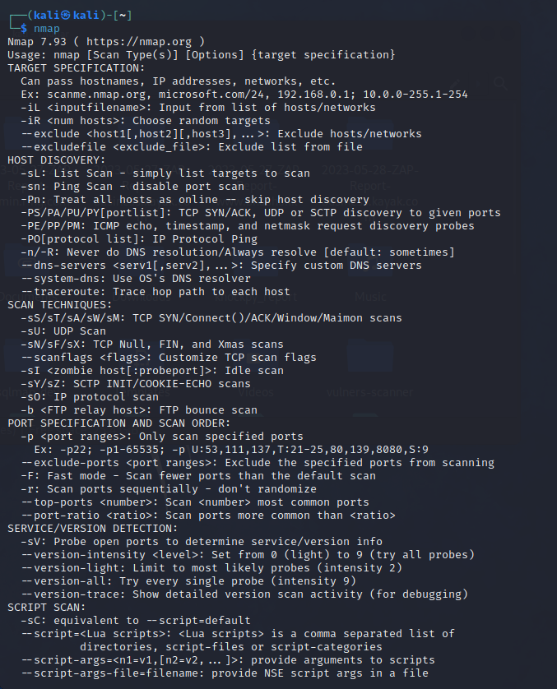

In this path all the script are stored

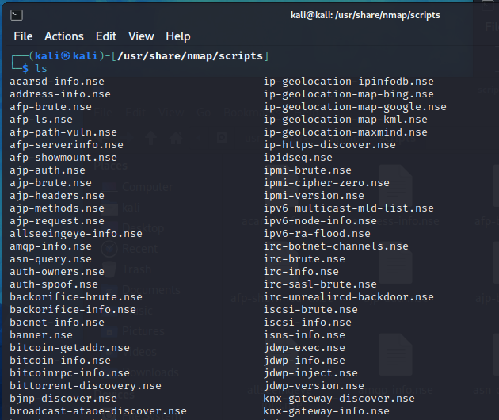

So if you want you can add the script

In this method can find use the nmap file :

Ex: - udo nmap -sV --script ssl-enum-ciphers 43.224.124.202

ssl-enum-ciphers is a file name

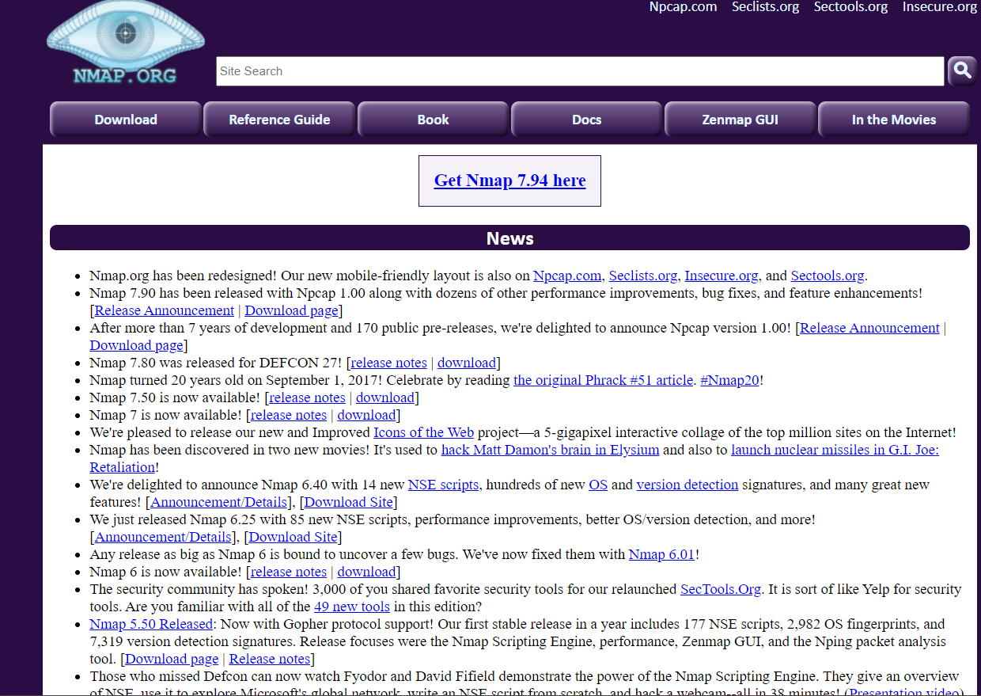

This is the official site, and you can get more details about the nmap command.

This is the sample output of the nmap.

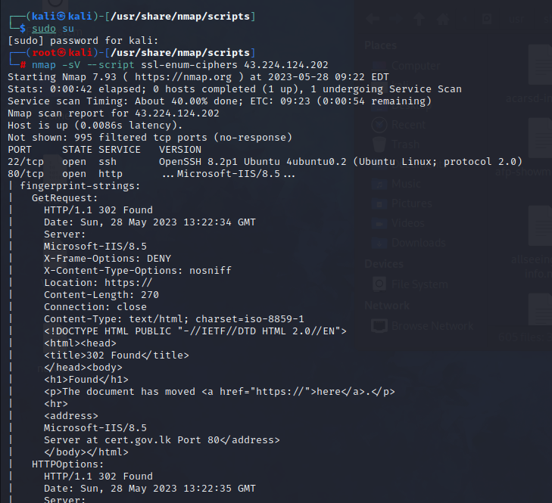

This is very powerful tool and you can search the open port set the exploit code with header and special thing is you can add the your own script in to this library and manually exploit the target.

In the nmap man you can see the all the command in use to nmap.

* **Techniques**

**Netspaker :-**

using this vulnerability assessment software, I can find 2 high vulnerabilities

1. - out-of-date version(jQuery) 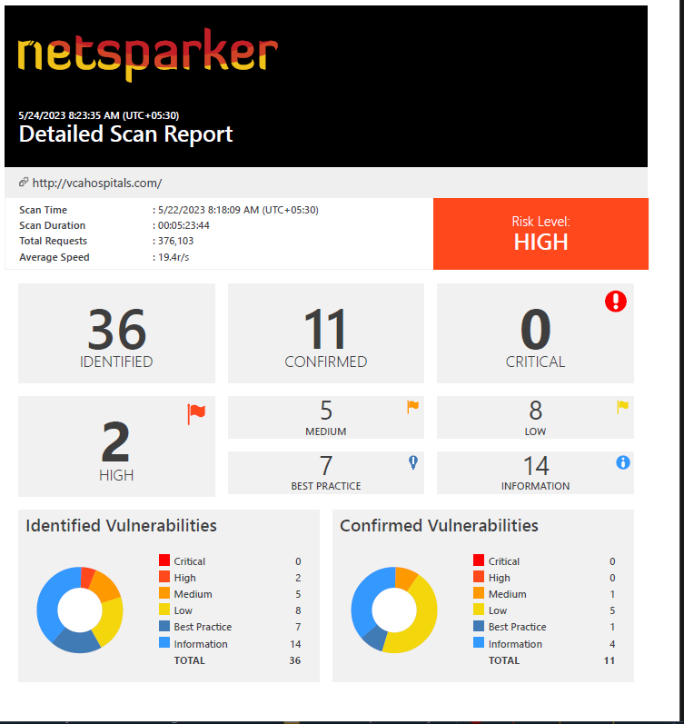

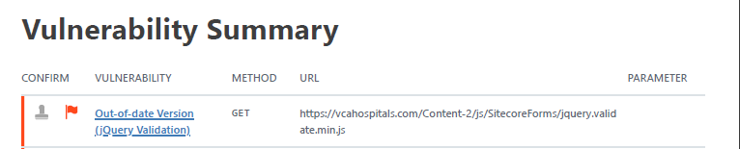

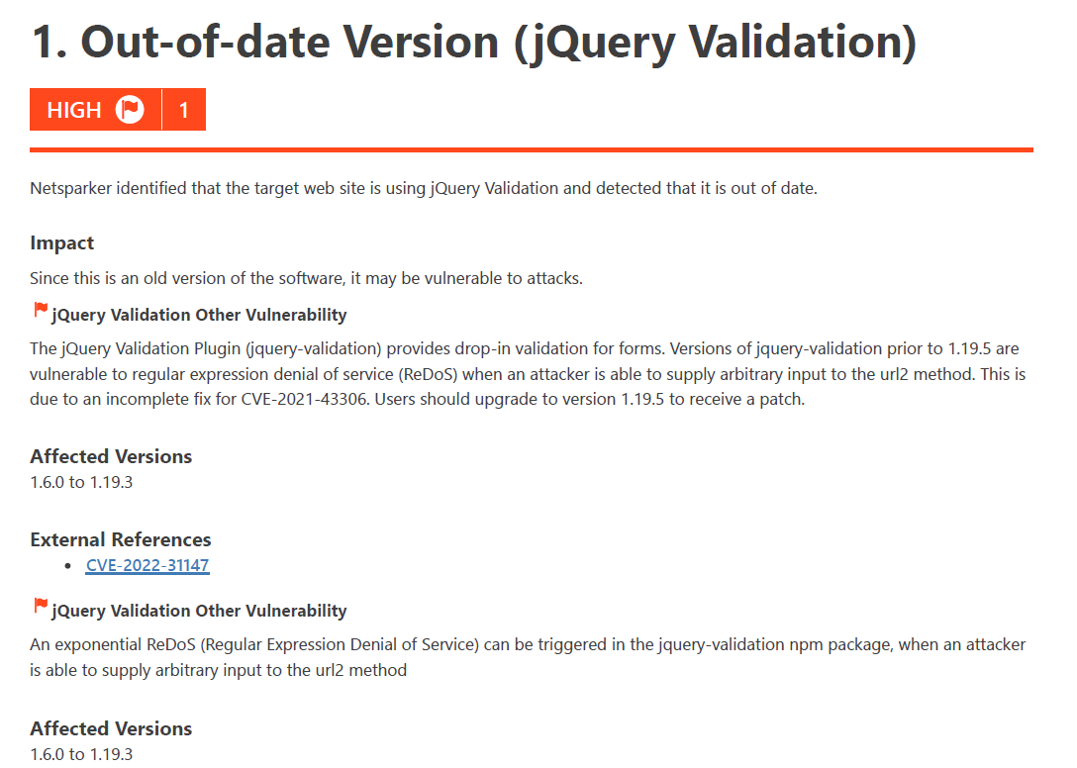

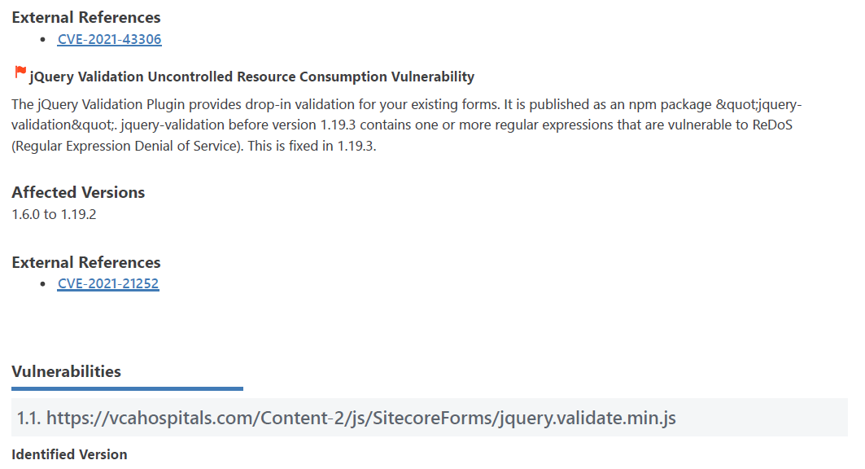

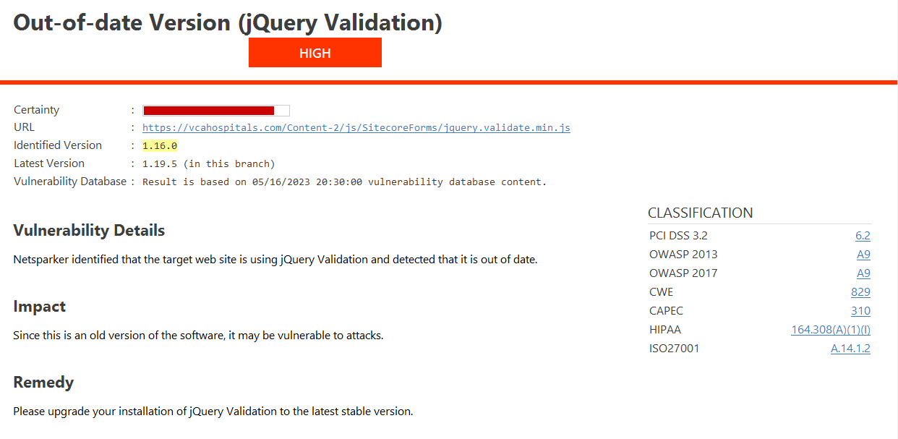

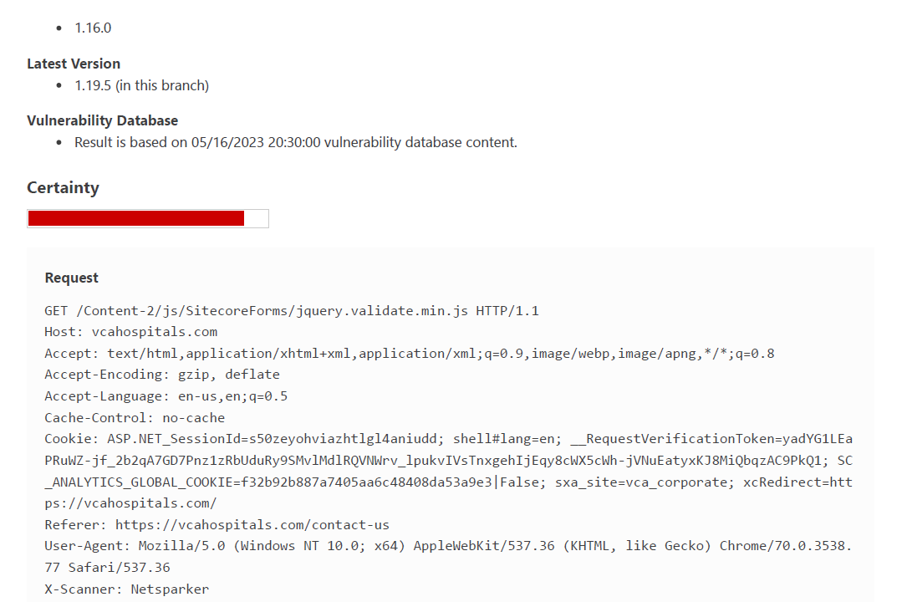

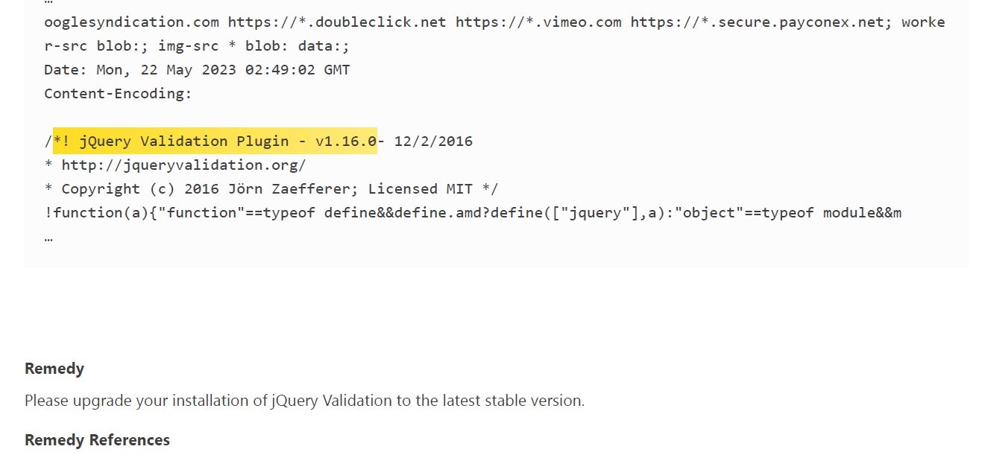

This Vulberbility confidence level is high and confirmed.

This may be affected to website strongly . so, if you want you can inject the exploit code with the burp suite and retrieve the information about the backend on the web site.

2)- out-of-date version(Moment.js)







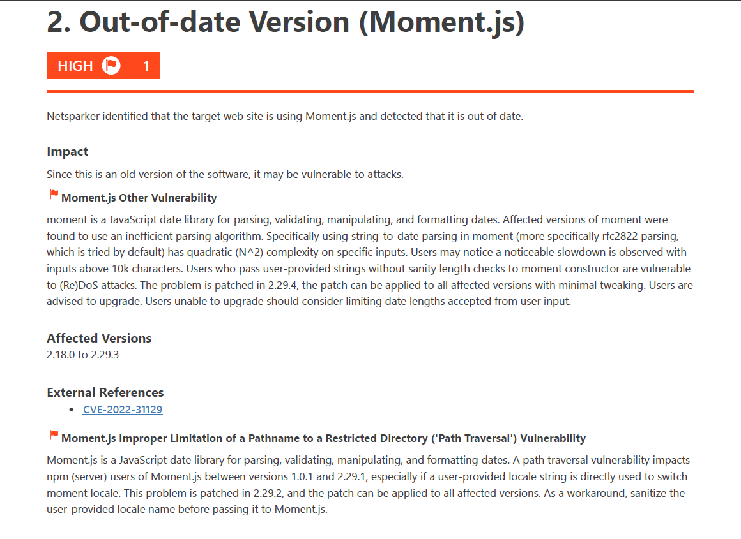

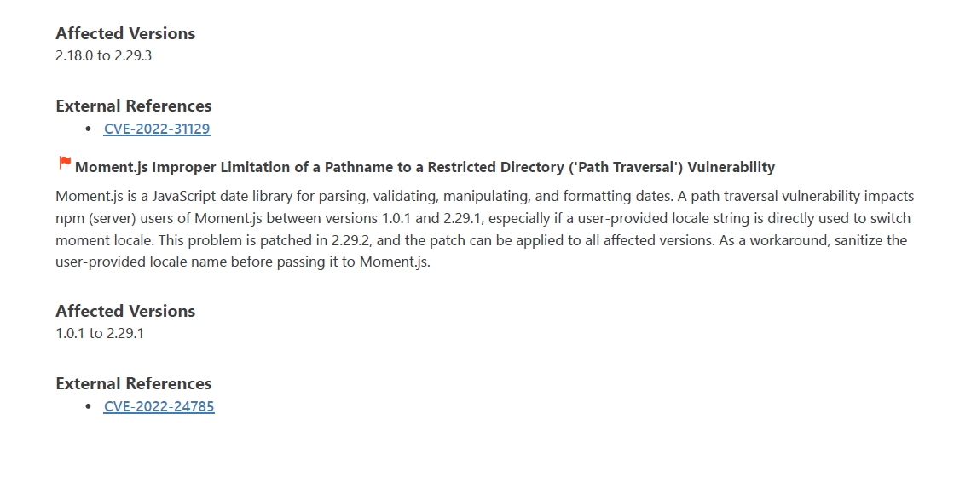

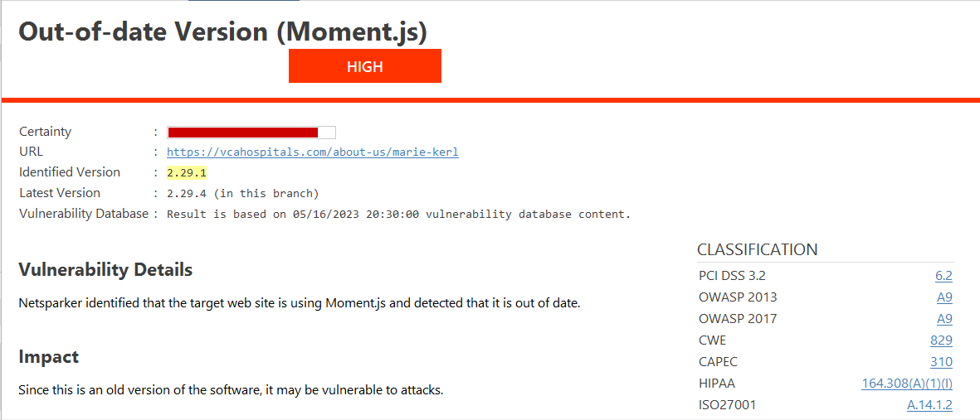

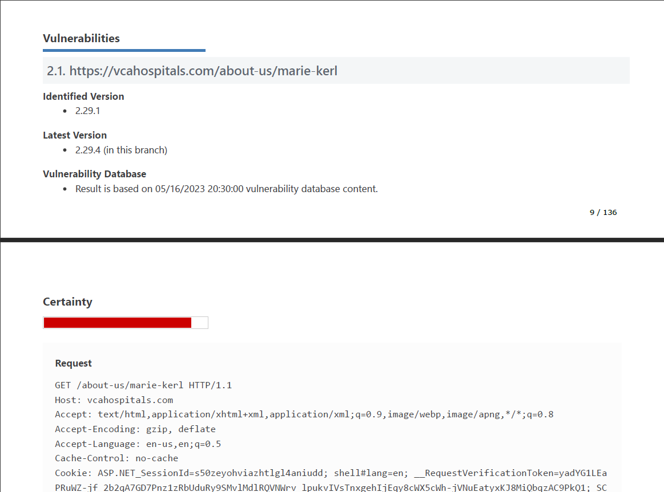

* **concepts learned**

out-of-date version(jQuery)

according to invicti

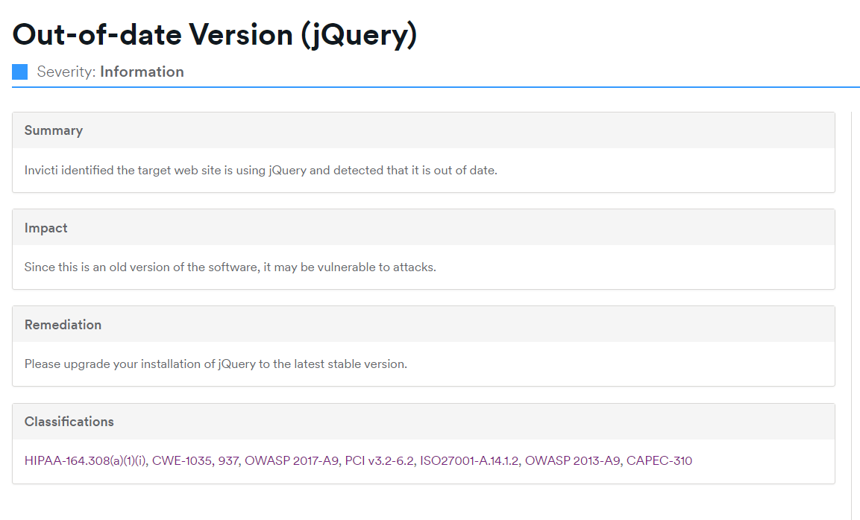

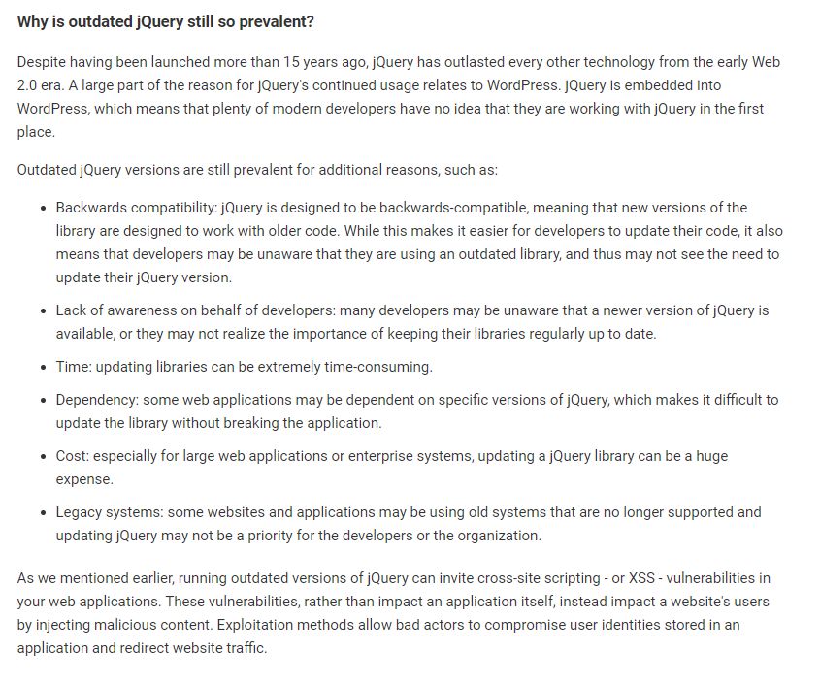

out-of-date version(moment.js)

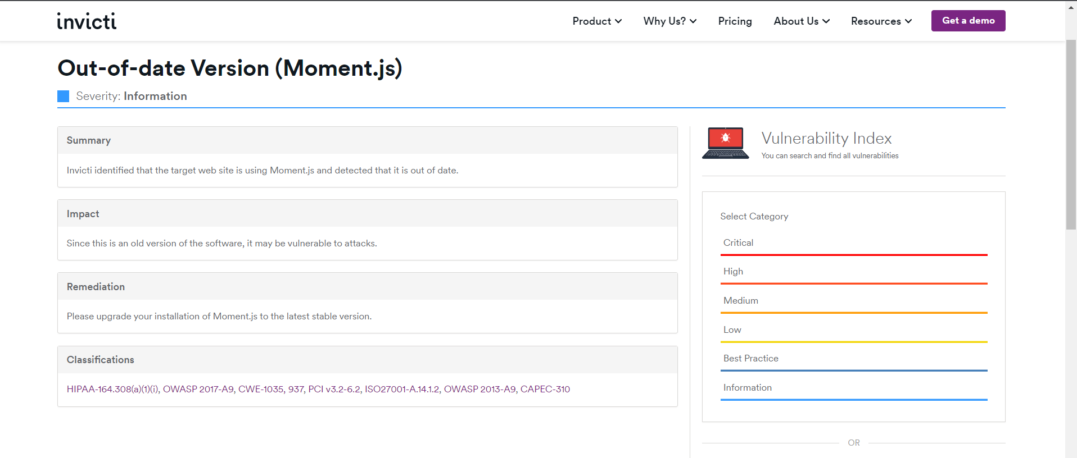

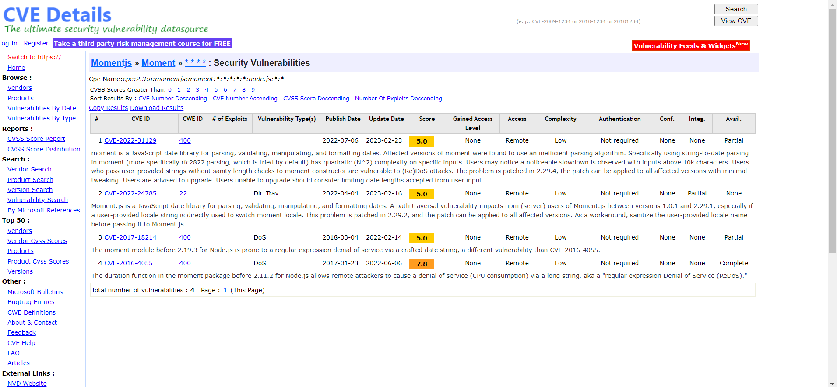



* **Reflections and takeaways**

When working with obsolete versions of libraries or frameworks such as Moment.js and jQuery, the following are some things to consider and take away from the experience:

The Importance of Maintaining Current Versions of Software Libraries that are not updated offer a security risk and may be missing critical bug fixes and performance enhancements if they are not kept up to date. It is essential to perform routine maintenance and updates on software components in order to keep them secure and running at peak performance.

Inadequately Updated Software May have Known Security flaws That may Be Exploited by Attackers Inadequately updated software may have known security flaws that may be exploited by attackers. It is absolutely necessary to keep up to speed with the newest security warnings and swiftly update to the most recent versions that fix these vulnerabilities.

Problems with Compatibility Using outdated versions of libraries might result in compatibility problems with other components or more recent technology. It is essential to take into account the compatibility needs of your project and to make certain that all dependencies are brought up to date in order to prevent any conflicts from occurring.

Enhancements to Both Performance and Optimisation Frequently Included in Library Updates Performance and optimisation improvements are frequently included in library updates. If you use the most recent versions of your programmes, you can experience increased productivity as well as enhanced speed thanks to these updates.

The most recent versions of libraries generally have active communities that offer assistance, documentation, and resources. These communities are also responsible for maintaining the libraries. Your access to the most recent updates, bug patches, and community assistance may be restricted if you stick to outdated versions of the software.

Testing for Migration and Compatibility It is crucial to evaluate the compatibility of your codebase before upgrading to newer versions. This allows you to make any necessary modifications or adjustments before moving forward. This guarantees that the relocation goes smoothly and reduces the likelihood of any potential problems.

Development Best Practises: An essential component of developing software is making it a habit to run scans for updates on a regular basis, maintaining awareness of newly released security patches, and adhering to industry standards for maintaining and controlling software versions. In order to ensure that your codebase is always up to date, it is essential to build processes and routines.

Learning Opportunities: Keeping your library up to date gives you the chance to investigate newly added features and enhanced capabilities. It is an opportunity to get new knowledge and modify your code in order to make use of the most recent capabilities made available by the upgraded versions.

You may improve the safety of your projects, as well as their performance and compatibility, by understanding the significance of maintaining the most recent versions of all software components and by adhering to best practises. Maintaining a consistent monitoring and update schedule for your dependencies can help to improve the overall stability and performance of your software solutions.

**10th May 2023**

**Summary of the day's activities**

**DoS** vulnerability identification utilizing **nmap** and any other tools to explore the website and locate high-level vulnerabilities.

**Vulnerabilities discovered or explored**

* Information gathering

🡪 HackerOne guide lines

URL: <https://www.kayak.com/>

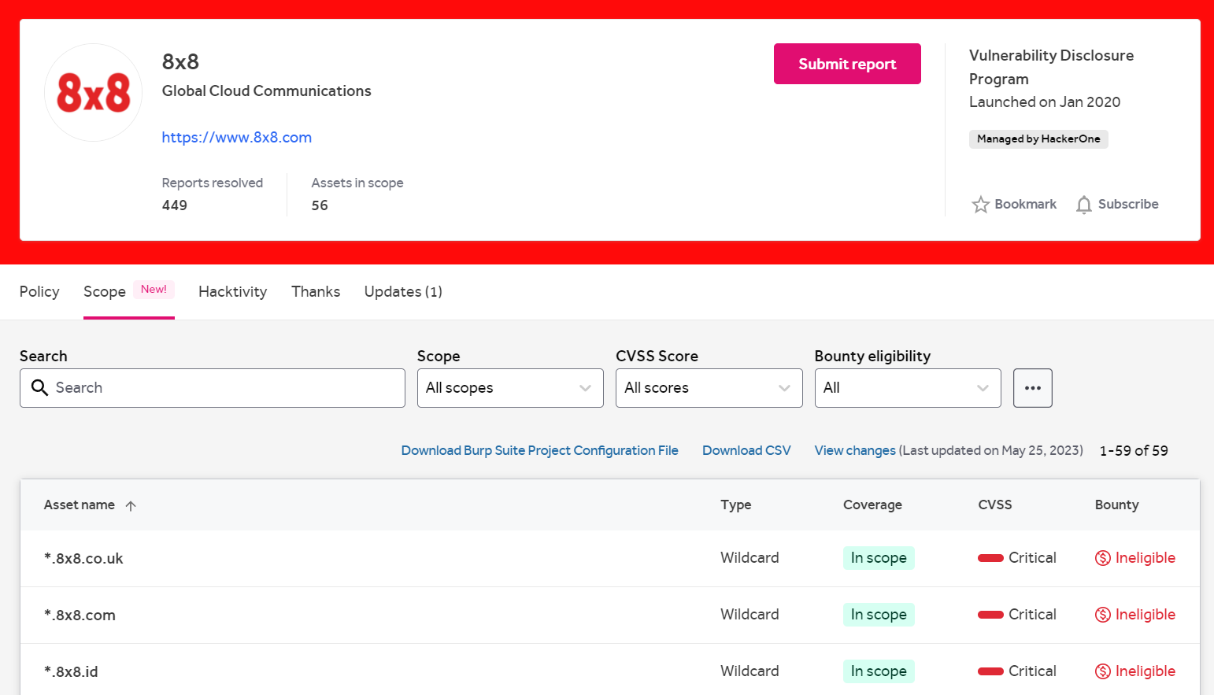

**Policy**

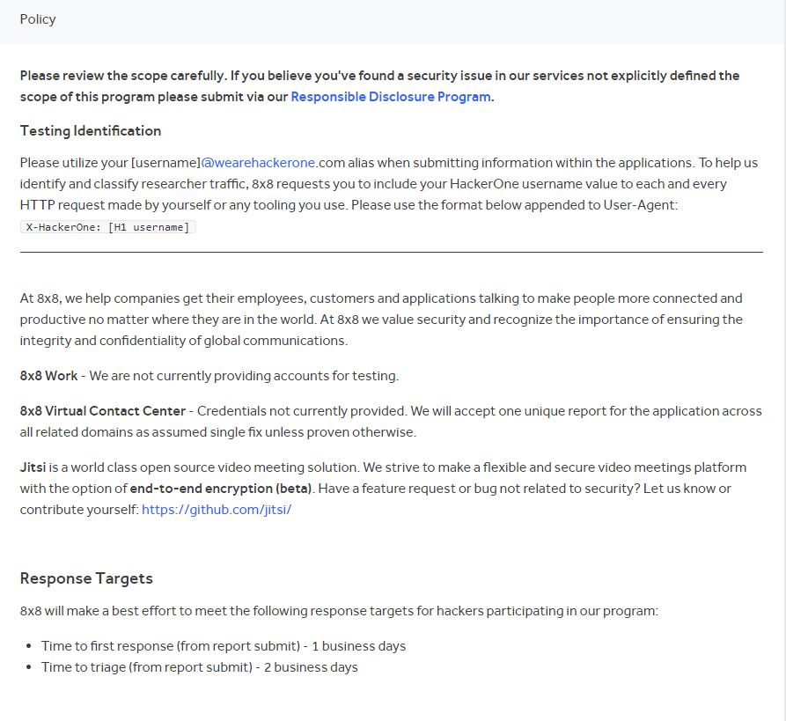

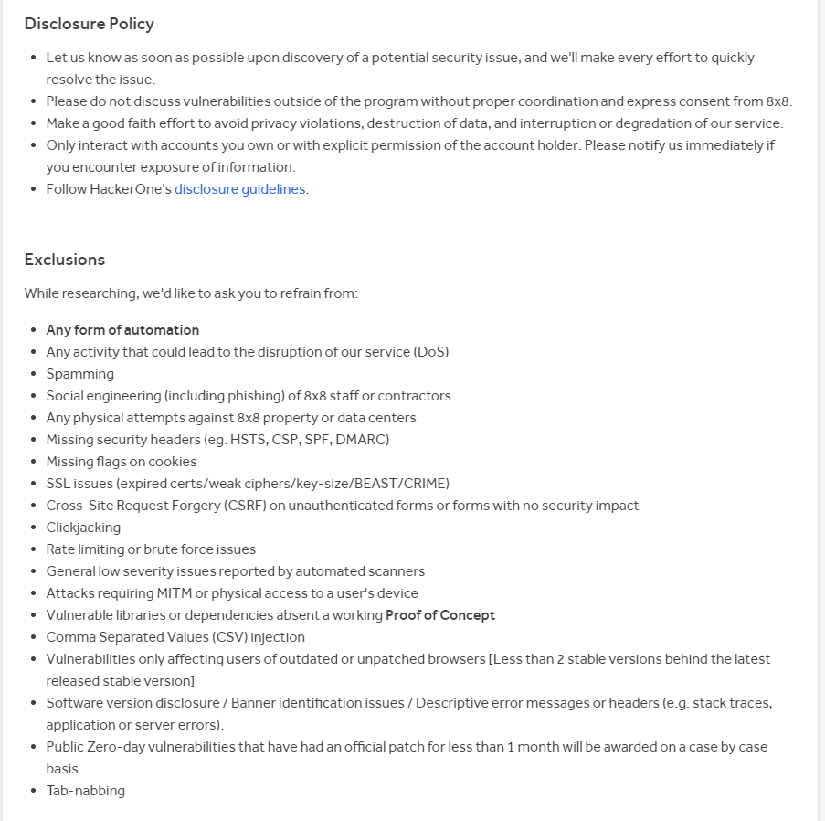

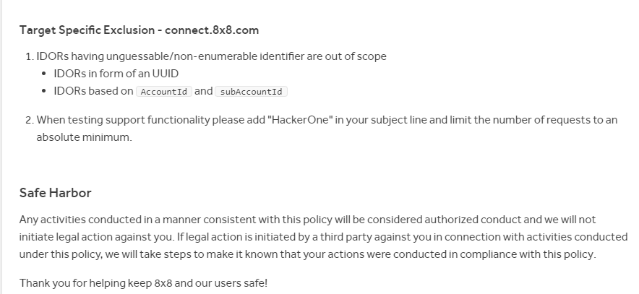

**Scope**

* In Scope

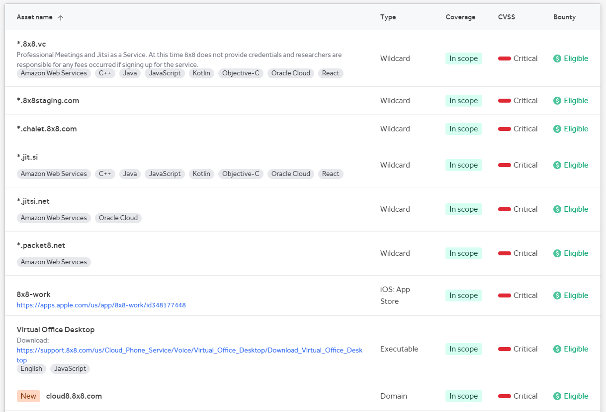

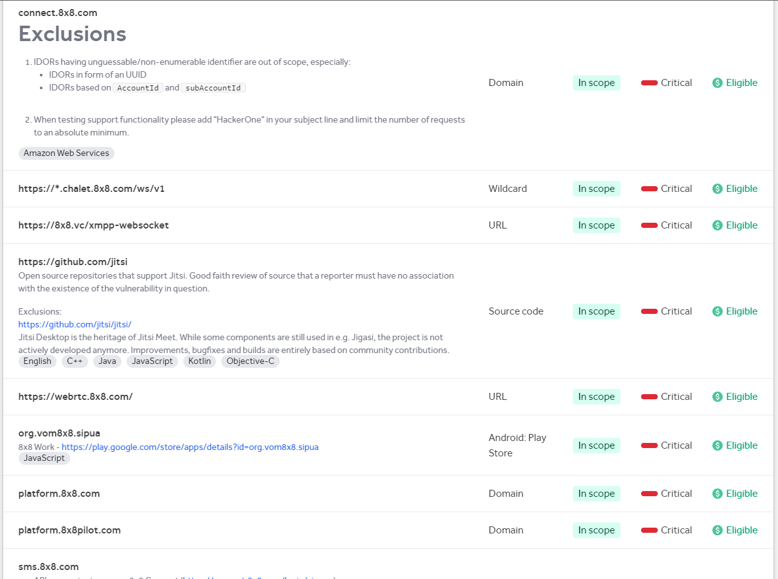

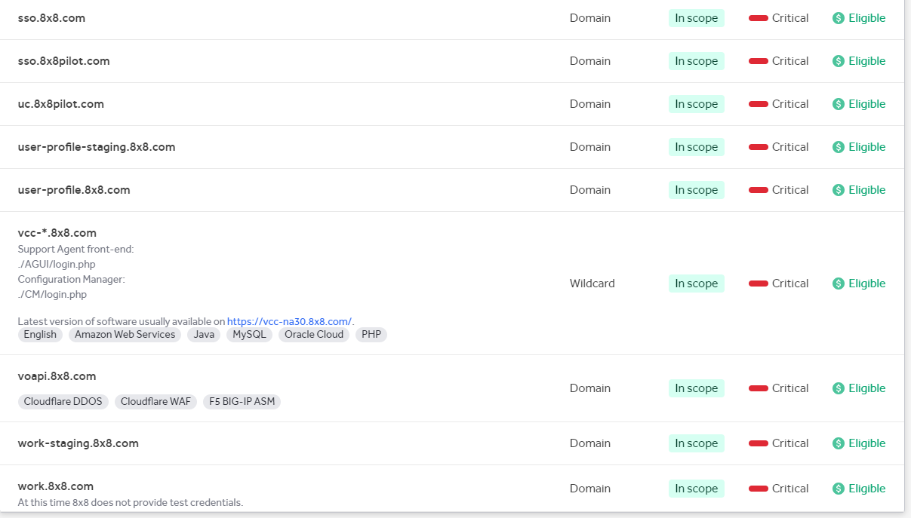

* Out Scope

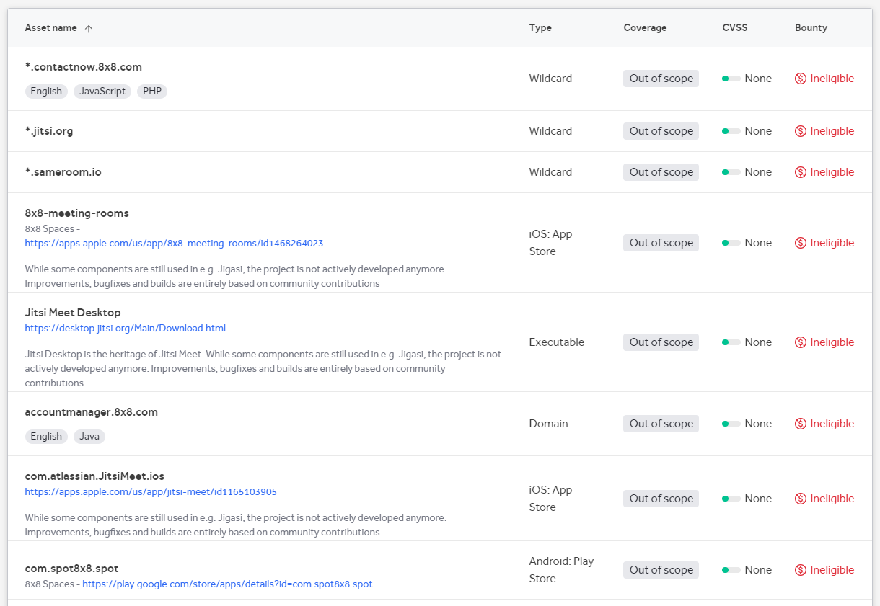

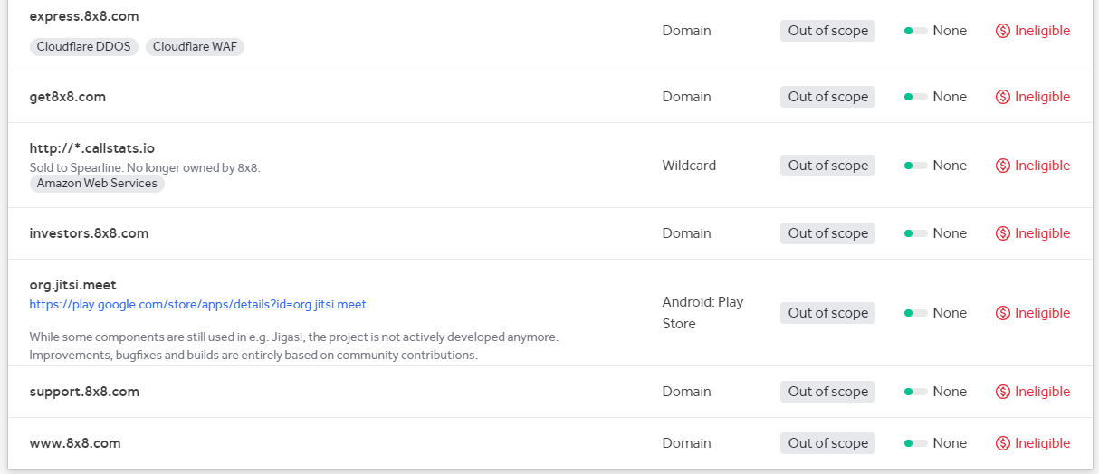

🡪 **About the website** (8x8.com)

The business 8x8 Inc. focuses in offering cloud-based business communication and collaboration solutions. The business provides a variety of cloud-based services, including phone, video, chat, and contact center solutions. These services are designed to assist organizations in streamlining their operations, enhancing consumer involvement, and improving communication.

The internet hub for 8x8 Inc. is the website 8x8.com. It offers details about the company's offerings in terms of goods, services, and solutions. The website offers information about the various communication and collaboration services offered by 8x8, customer success stories, access to resources like whitepapers and webinars, and contact information for the sales department.

Typical sections of the webpage include:

Services and Goods: The various services provided by 8x8, such as cloud phone systems, video conferencing, team messaging, and contact center solutions, are highlighted in this section. It outlines the characteristics and advantages of each product.

The needs of several industries, including healthcare, financial services, retail, and professional services, are catered for by 8x8 in its solutions. The benefits of the company's communication solutions for various industries are highlighted in this section.

Whitepapers, e-books, case studies, and blog posts about communication and collaboration trends, best practices, and industry insights are frequently available to website users in a section devoted to resources.

Customer Success: This area may provide customer success tales and recommendations that show how 8x8's products have benefited organizations in various industries.

Contact Information: The website often includes contact information that enables users to get in touch with 8x8's sales team or customer support for questions or assistance, such as phone numbers, email addresses, and a contact form.

* + About the Sub Domain that are discovered (**voapi.8x8.com**)

Voice over Internet Protocol, or VoIP, is a technology that makes it possible to have multimedia conversations and voice calls over the internet. VoIP transforms voice signals into digital data packets that are transmitted via an IP network as opposed to using conventional phone lines.

VoIP services are among the cloud-based communication options that 8x8 is renowned for offering to enterprises. With the help of their cloud infrastructure, they provide a variety of VoIP products and solutions that enable dependable and feature-rich communication.

The domain name "voapi.8x8.com" suggests that it might be connected to the API (Application Programming Interface) that 8x8 offers for integrating their VoIP services into apps or systems developed by third parties. With the use of APIs, programmers can connect with a platform or service—in this case, the VoIP services offered by 8x8—to create unique apps, automate procedures, or incorporate communication features into current systems.

It's crucial to highlight that I am unable to provide detailed information regarding the current functionality or use of the "voapi.8x8.com" domain because I do not have immediate access to the internet. I advise visiting the official 8x8 website or contacting the 8x8 support staff directly to get the most precise and recent information on the 8x8 VoIP API.

**Challenges faced and how they were overcome**

Challenging to visit the webpage

That website restricted my IP address and then I use a VPN for resolve that problem.

Taken more time than expected for scanning .

* **New tools**

**🡪Sublist3r**

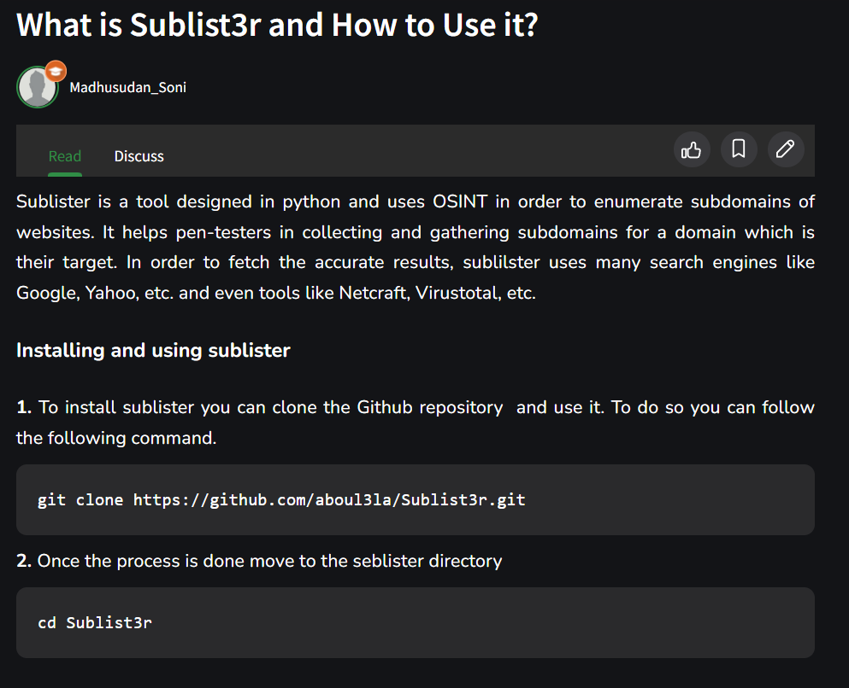

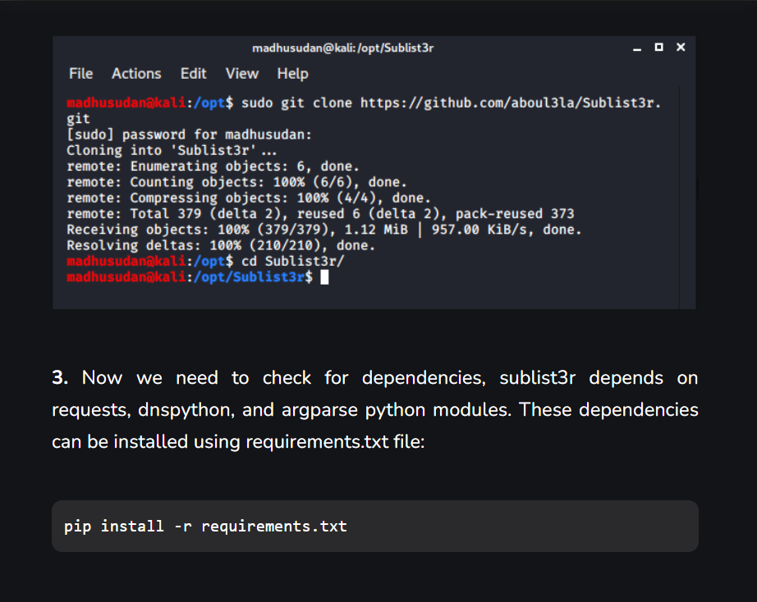

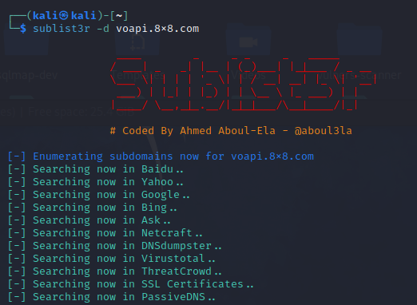

**Command for sublist3r:** sublist3r -d voapi.8x8.com -t 3 -e bing

* **Techniques**

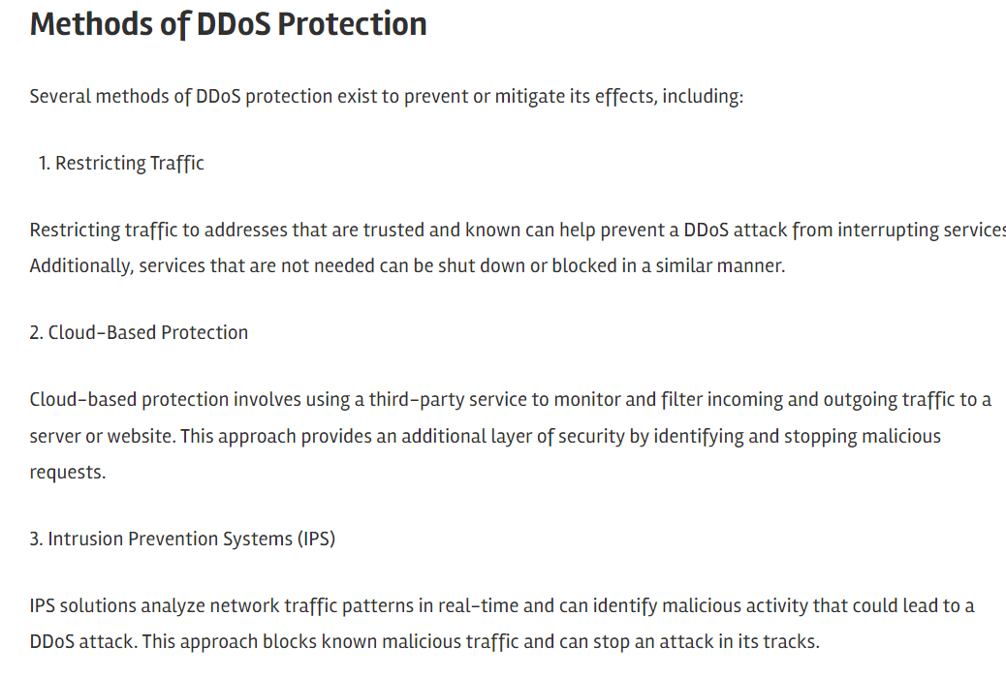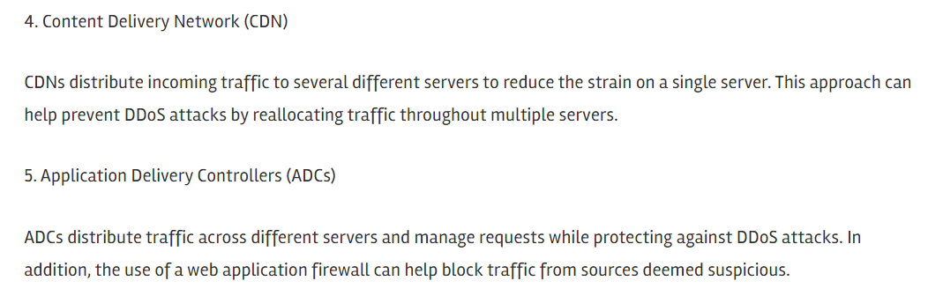

* **concepts learned**

# DoS

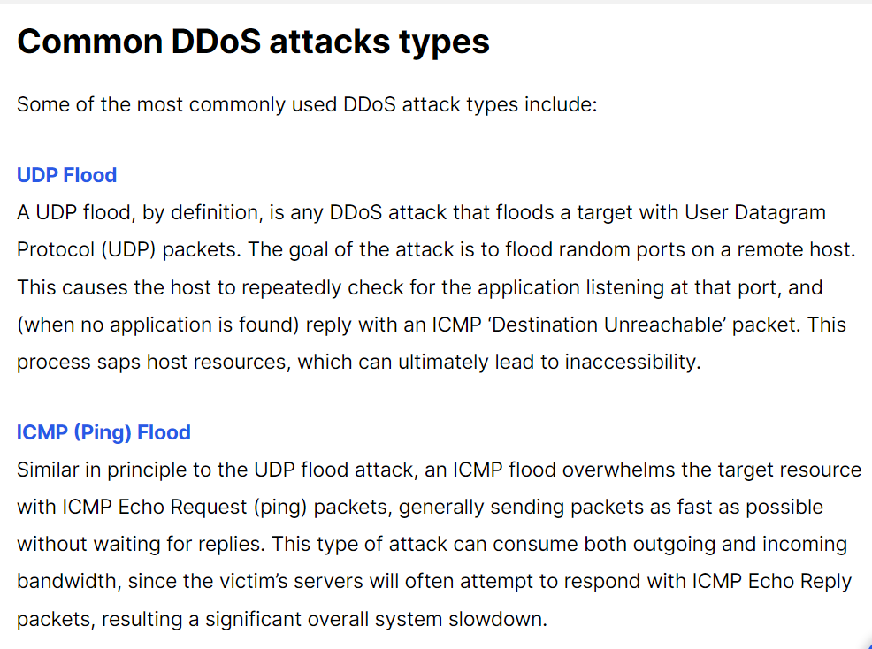

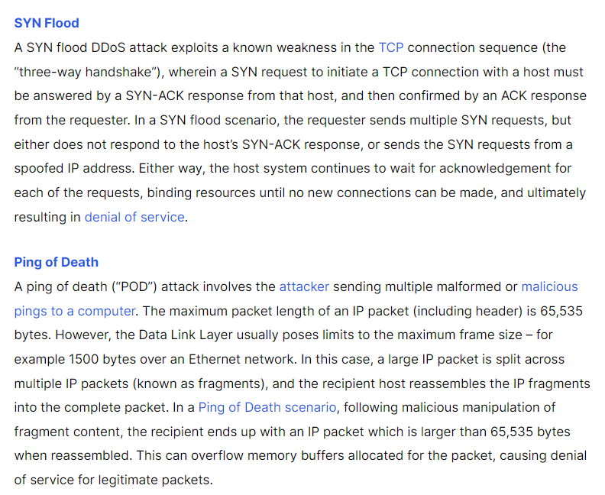

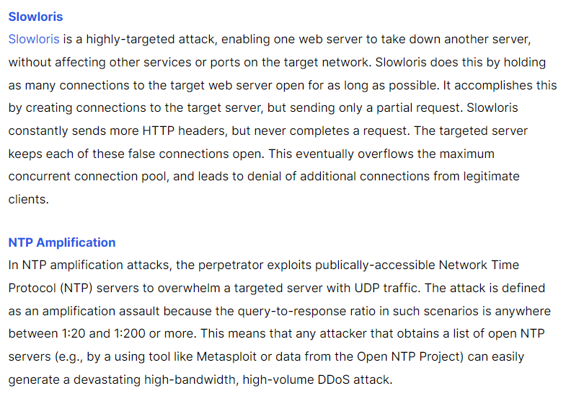 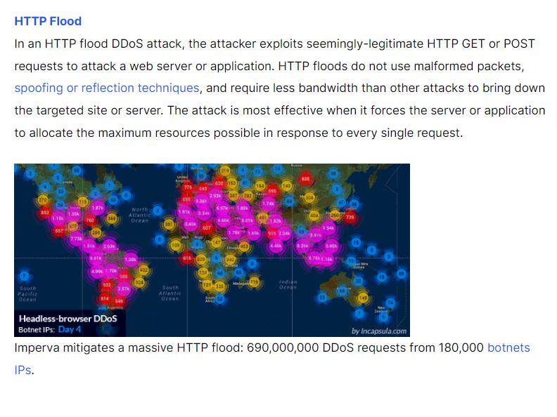

**Reflections and takeaways**

DoS attacks frequently highlight flaws or vulnerabilities in a system's infrastructure, network, or application. Reflections on the assault can aid in locating these weaknesses and motivate firms to put the required security measures in place to prevent further attacks.

Incident response and mitigation: The need of having a strong incident response plan in place is highlighted through reflections on a DoS assault. Organizations can assess the success of their response activities, spot any flaws, and adjust their incident response plans as necessary.

Optimization of the network and applications: DoS attacks might reveal performance bottlenecks and places that need network or application optimization. Businesses can take advantage of the attack to assess and upgrade their infrastructure, increasing their resilience to similar attacks in the future.

DDoS defense: A common variation of DoS attacks is Distributed Denial-of-Service (DDoS) assaults, in which numerous sources overwhelm a target. The need for DDoS defense systems, such as traffic filtering, rate limiting, or using specialized DDoS mitigation services, can be highlighted by reflections on a DoS attack.

DoS assaults serve as a stark reminder of the need of proactive monitoring and real-time alerting systems. In order to ensure faster response times in the future, organizations can examine their monitoring capabilities, determine whether they were able to quickly identify the assault, and strengthen their monitoring infrastructure.

Reflections on a DoS attack frequently highlight the value of teamwork and excellent communication between IT teams, security personnel, and stakeholders. Organizations can take use of this chance to improve communication channels, plan joint responses, and raise public understanding of DoS attack mitigation and preventative measures.

Employee training and awareness: DoS attacks might act as a reminder to fund ongoing employee training and cybersecurity awareness initiatives. Organizations may decide to teach workers how to spot and report suspicious activity, reiterate best security practices, and continue vigilant in response to reflections on the assault.